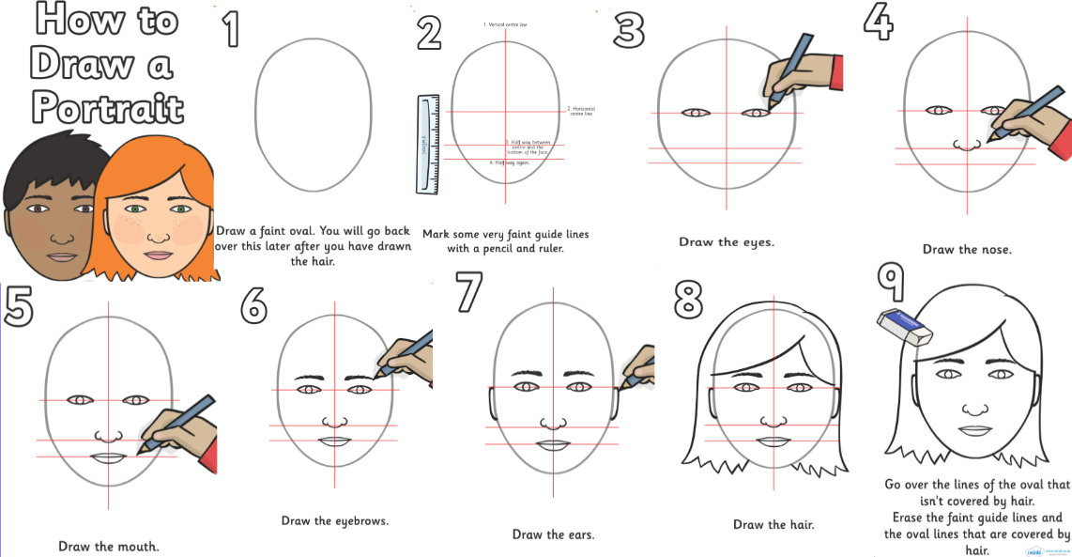
Create a self - portrait. If you can, email it to me so I can have a look!

