Art:
- Sketching
- Please find an object at home.
- Place it on a flat surface.
Have a go at sketching it onto some paper. Think of how you can create shadows and how you can sketch the different shapes that the object has.
To watch: - https://www.youtube.com/watch?v=ewMksAbgdBI

- Easter
- Using a piece of paper, draw the outline of an Easter Egg.
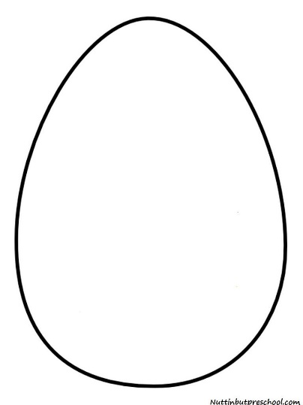

- Find something in your house that is circular (e.g. Bottle Lid, Toilet Roll, cups).
- Draw circles using those objects in the outline of the egg.
- Then, using paint or colouring pencils, colour in the different sections that are created using the circles.

