Classifying Organisms

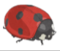
Research different animals found in a British woodland.

How many can you find?

Be a taxonomist and classify these animals! Remember, first sort into two groups then turn into four, then into eight…
