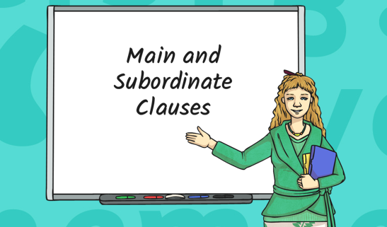

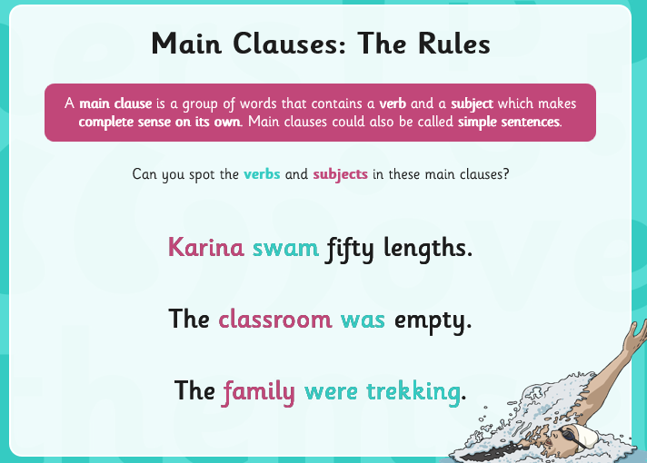

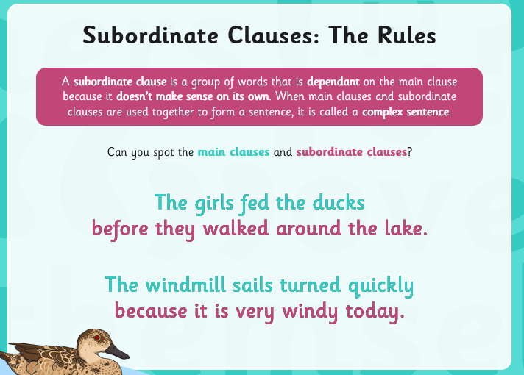

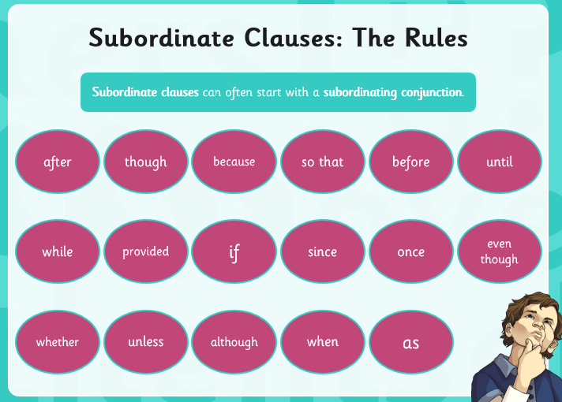

Activity 1
Look at the subordinating conjunctions above and use them to write your own sentences.
Write at least 5 sentences (year 6, not year 3 level!!!) and remember to use : ; ( )

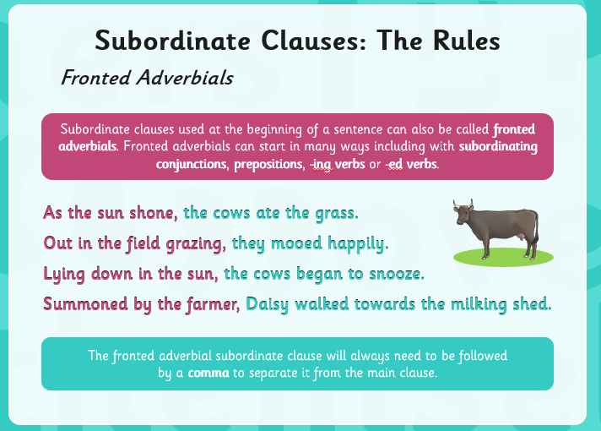
Activity 2
Write 5 sentences using the most adventurous fronted adverbials you can (yr 6 not yr 3!).

