Foxes, Life Skills 30/03/20

L.O. Can I read a time table and plan a journey?

Miss. B. has a meeting at school on Tuesday 31st March at 11.50am.

She is starting and ending her journey from Ashford town centre and is catching the bus.

The meeting will finish at approximately 12.50pm.
Can you help Miss. B. plan her journey by finding the best-timed busses for her journey there and back?
What time will she be back in Ashford?

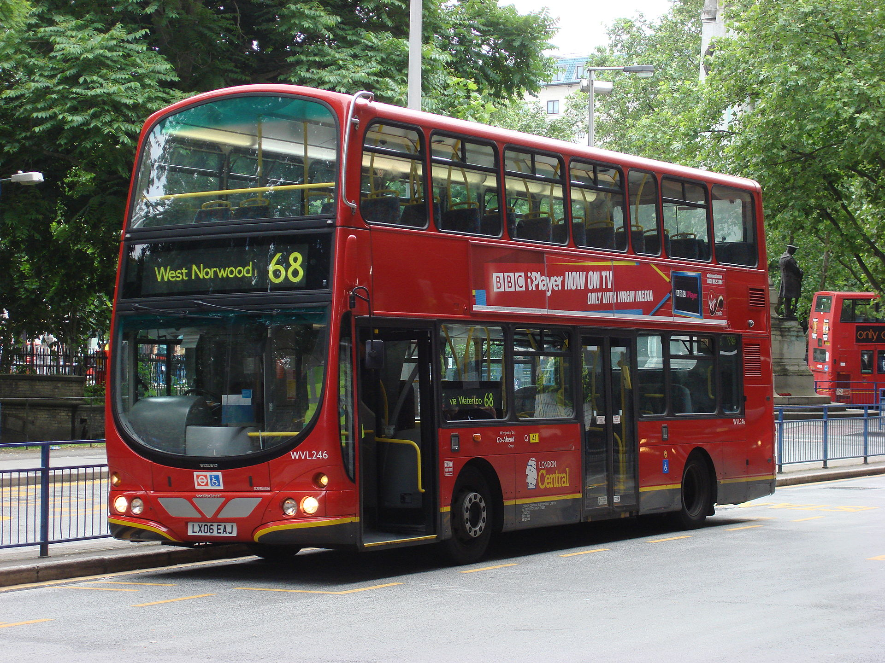

Badgers, Life Skills 30/03/20

L.O. Can I read a time table and plan a journey?

Miss. B. has a meeting at school on Tuesday 31st March at 11.50am.

She is starting and ending her journey from Ashford town centre and is catching the bus.

The meeting will finish at approximately 12.50pm.
Can you help Miss. B. plan her journey?
Where in Ashford should Miss. B. get the bus from?
What number and what time bus should Miss. B. get so she’s not late for her meeting?
What time and number bus will take her back to Ashford?
What will the time be when she’s back in Ashford?

Extension: What about the train, which would be best?

Owls, Life Skills, 31/03/20

L.O. Can I read a time table and plan a journey?

Miss. B. has a meeting at school on Tuesday 31st March at 11.50am.

She is starting and ending her journey from Tesco, Park Farm, Ashford and is catching the bus.

The meeting will finish at approximately 12.50pm.
Can you help Miss. B. plan her journey?
What number and what time bus should Miss. B. get so she’s not late for her meeting?
Are there any stops and changes along the way?
What time and number bus will take her back to Tesco?
What will the time be when she’s back?

Extension: what about the train, which would be best?

