ICT – Good Morning Foxes and Badgers.
Please can you logon to Purple Mash and check your ‘To Do’ section (shown below).
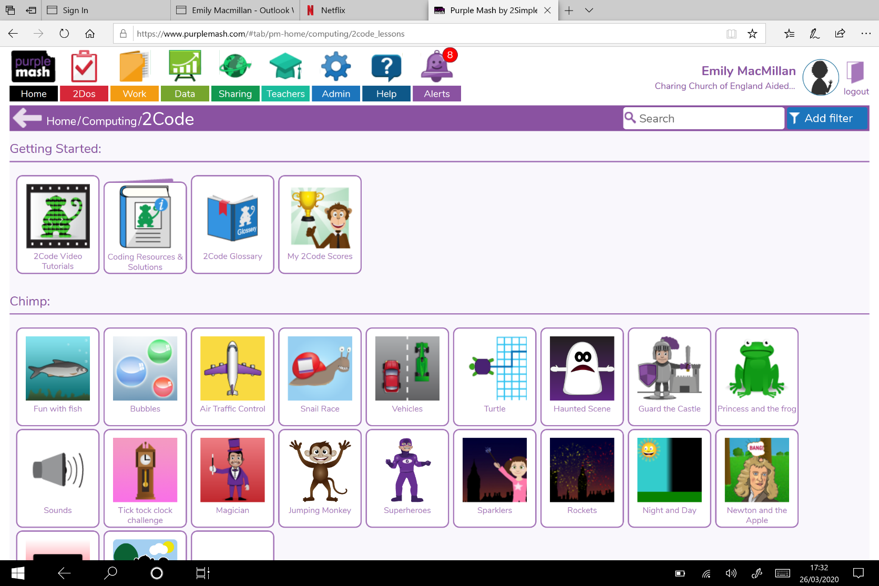

In your ‘To do’ section, there will be 2 activities for you to do.
Foxes:
- 2DIY3D – Creating your 3D game.
- Turtle – Make sure you watch the videos to help move the turtle around the board.
Badgers:
- 2DIY3D - Creating your 3D game.
- Vehicles 2 – Make sure you watch the video to help you complete the challenges.

