Maths – Have a go at these money subtraction questions.

[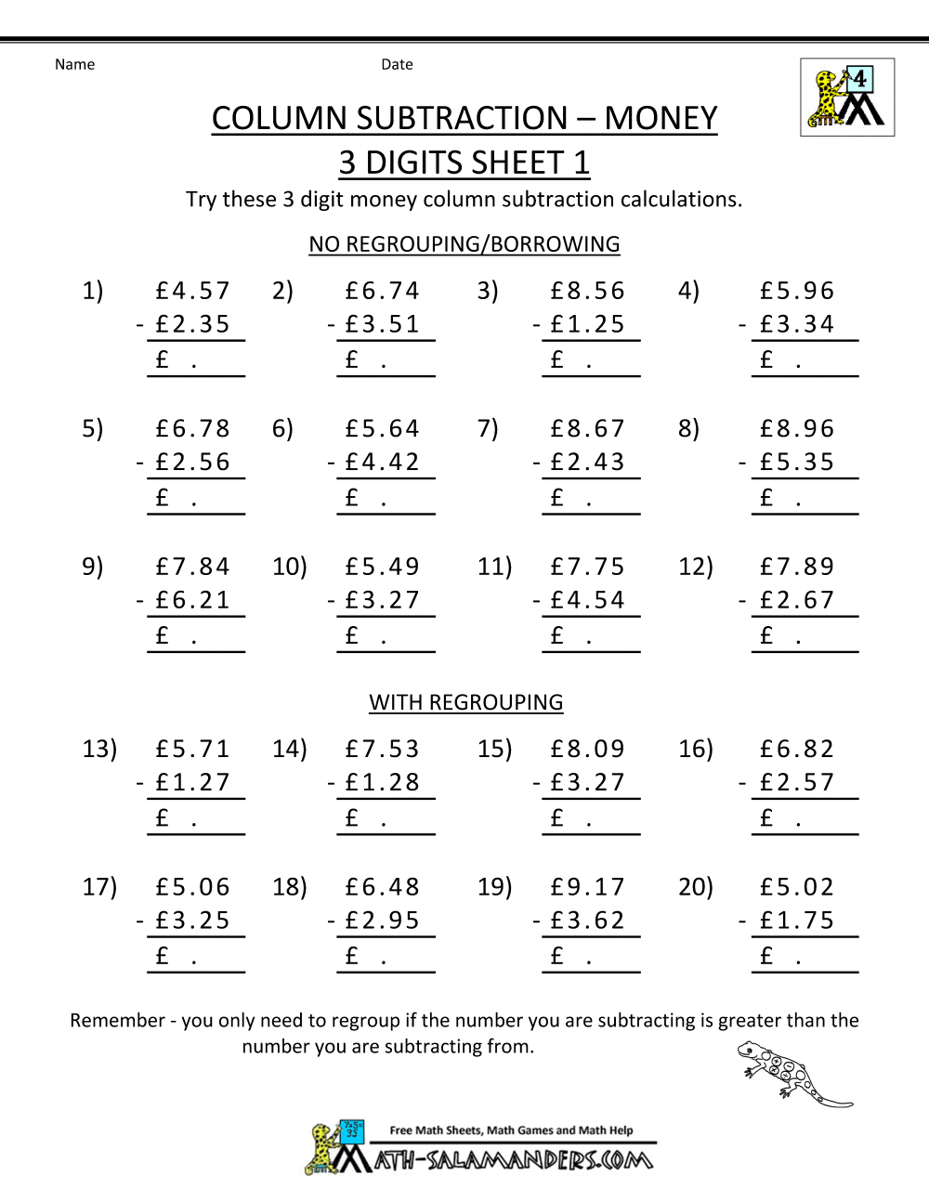](https://www.google.co.uk/url?sa=i&url=https%3A%2F%2Fwww.pinterest.com%2Fpin%2F174514554290688898%2F&psig=AOvVaw0-hzcJ1jWCm62zKqB-g1WF&ust=1585586426445000&source=images&cd=vfe&ved=0CAIQjRxqFwoTCLiA7u-PwOgCFQAAAAAdAAAAABAJ)Green

Red

[](https://www.google.co.uk/url?sa=i&url=https%3A%2F%2Fwww.pinterest.com%2Fpin%2F174514554290688898%2F&psig=AOvVaw0-hzcJ1jWCm62zKqB-g1WF&ust=1585586426445000&source=images&cd=vfe&ved=0CAIQjRxqFwoTCLiA7u-PwOgCFQAAAAAdAAAAABAJ)

12.

11.

10.

9.

8.

7.

6.

5.

4.

3.

2.

1.

Blue

[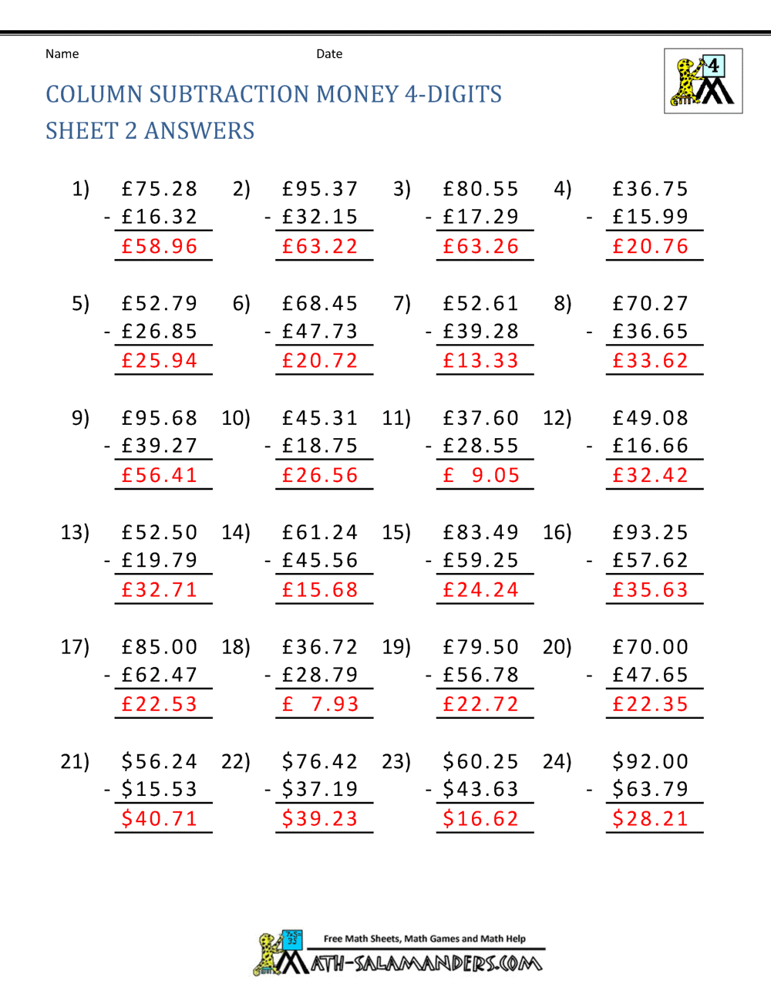](https://www.google.co.uk/url?sa=i&url=https%3A%2F%2Fwww.math-salamanders.com%2Fsubtracting-money-worksheets.html&psig=AOvVaw24Pm7HT-eGQBzJeNkEXCPf&ust=1585586878438000&source=images&cd=vfe&ved=0CAIQjRxqFwoTCLDaqciRwOgCFQAAAAAdAAAAABAJ)