[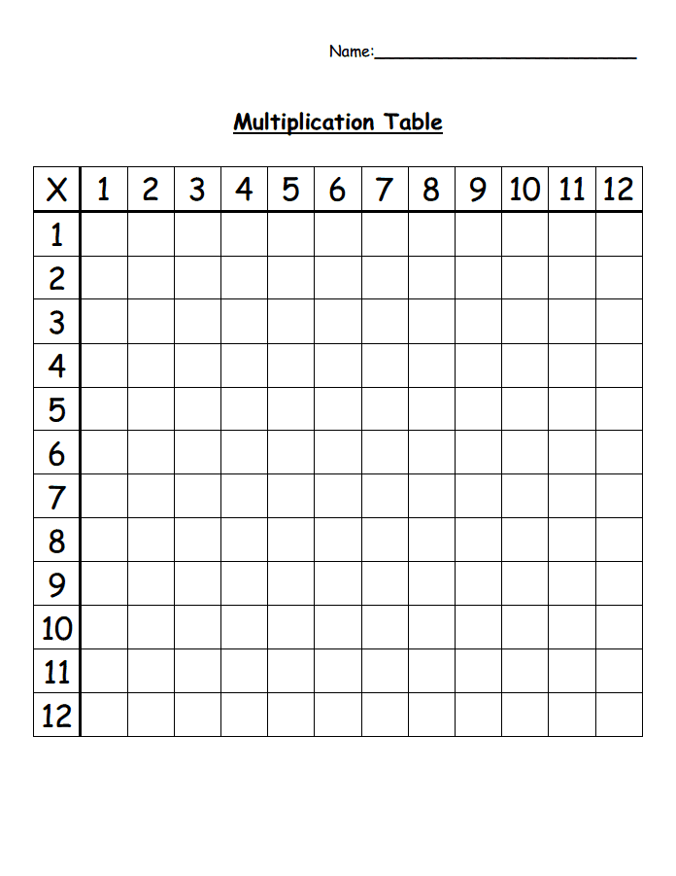](https://www.google.co.uk/url?sa=i&url=https%3A%2F%2Fwww.pinterest.com%2Fpin%2F198791771024620921%2F&psig=AOvVaw1__XRTJT1ab1x9Al6ulm-B&ust=1578952591919000&source=images&cd=vfe&ved=0CAIQjRxqFwoTCMCmtvSG_-YCFQAAAAAdAAAAABAI)