RE - Week beginning 23.03.20
What Does The Bible Say About Death?

Desmond Tutu is a South African Anglican cleric and theologian known for his work as an anti-apartheid and human rights activist.
He was the Bishop of Johannesburg from 1985 to 1986 and then the Archbishop of Cape Town from 1986 to 1996, in both cases being the first black African to hold the position.

Tutu was born of mixed Xhosa and Motswana heritage to a poor family in Klerksdorp, British Imperial South Africa. In 1960, he was ordained as an Anglican priest. He took an active role in opposition to South Africa's apartheid system of racial segregation and white-minority rule.

He changed the structure of leadership within the church and oversaw the introduction of women priests. Tutu has campaigned for gay rights and spoken out on a wide range of subjects, among them the Israel-Palestine conflict and his opposition to the Iraq War.
He was internationally praised for his anti-apartheid activism, receiving a range of awards, including the Nobel Peace Prize.

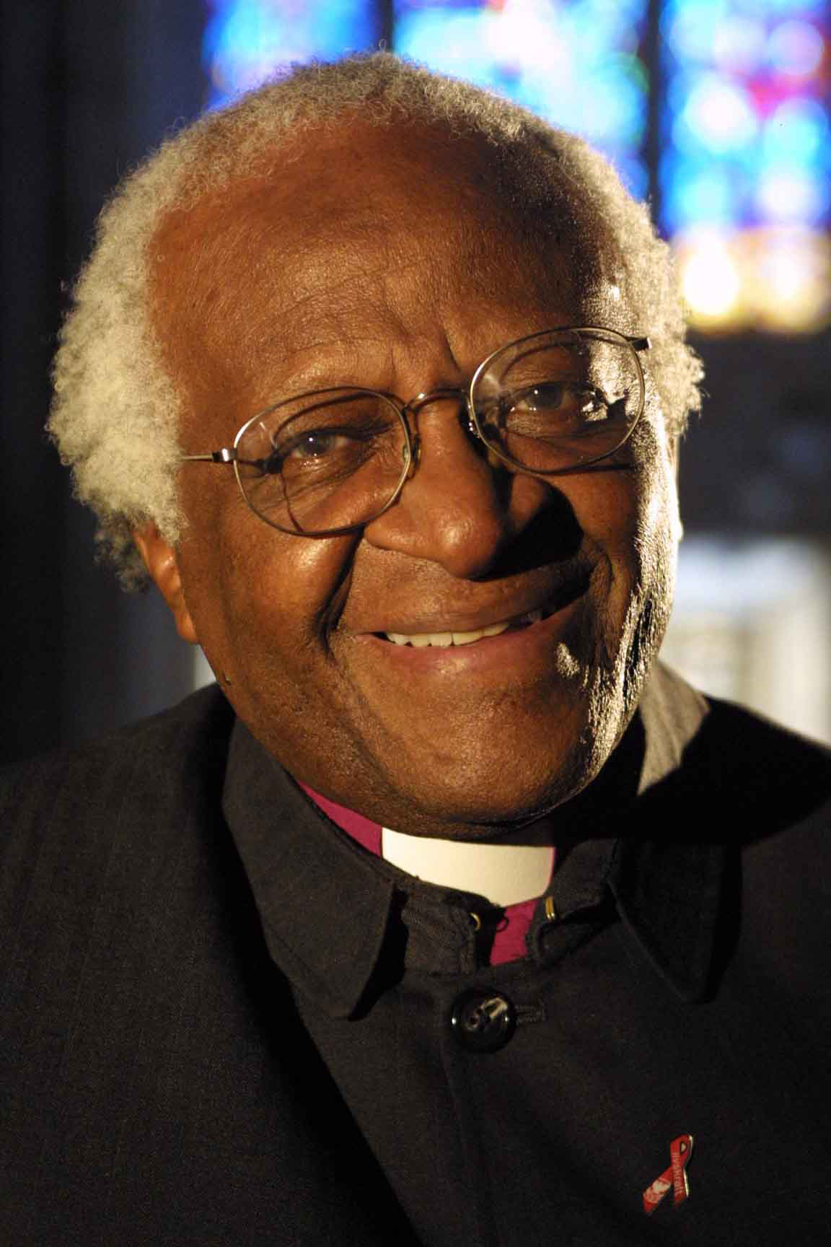
Desmond Tutu received many threats, including death threats, in the 1980s, for his fearless opposition to racism in South Africa.
He said that he was not scared to continue to speak out: ‘What can they do to me? They could kill me. But death is not such a terrible thing, for a Christian.’

Why is it that many Christians feel that the resurrection of Jesus means that death is not the end?

Look at these bible verses that are used at funerals. 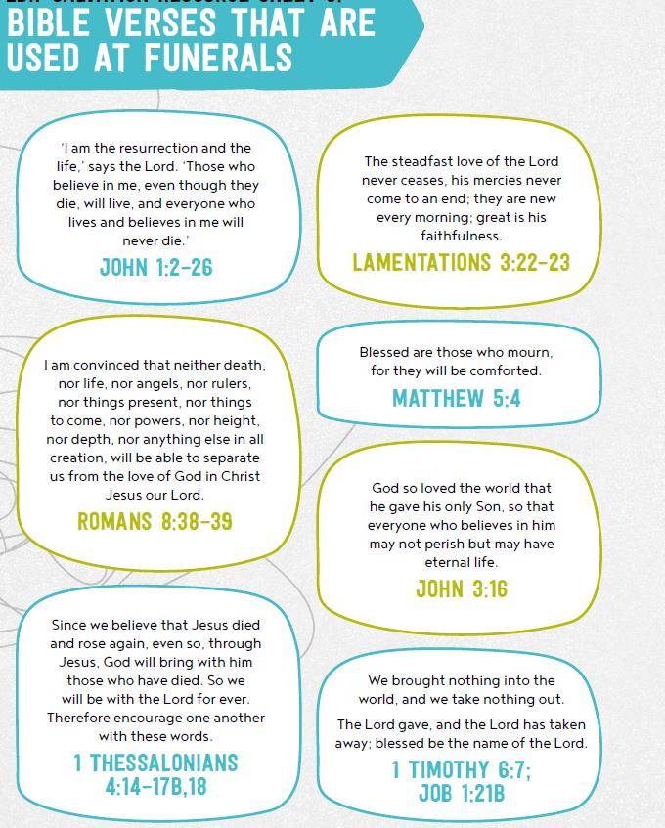
What do you think it is telling Christians? What comfort or hope might it bring them? Which one do you prefer? Why?

Activity

Write a poem or a reading that could be read at a Christian funeral.

Key Words:
death faith
loss resurrection
joy heaven
God Jesus
joyful salvation
Christian hope
eternal life peace
God's Kingdom

