Rabbits Home Learning 2
Maths:
Find a coat hanger and 10 pegs. Find different ways to arrange the pegs to make 2 numbers.
Challenge:
Write the number sentence.
e.g. 4 + 6 = 10
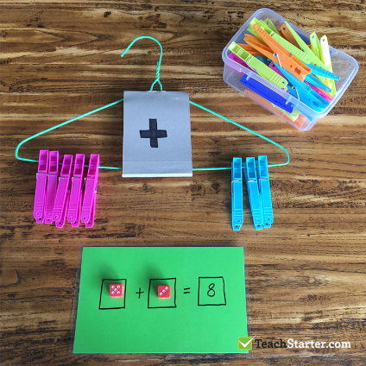

Reading:
Read your reading book to an adult. Then ask them to read it to you and ask then play ‘jump in’.
This is when the grown up reads and the child follows the words and pauses on a word and the child ‘jumps in’ with the correct word. The story needs to be familiar first though.
Writing:
Please practise letter formation, below are the letters and the correct formation.
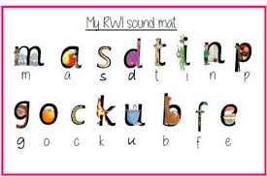
Practise with pens, pencils or chalks. You could even try dipping your finger in ketchup and use your finger to write the letter on a plate!

Have a look in your garden and see if there are any new plants starting to grow. Ask a grown up if you can find a weed and gently pull it up to see the roots. What do they look like?

