Rabbits Home Learning 5 30.3.20

Reading:
Use the ‘alphablocks’ website on cbeebies. Watch episodes, play games or do some of the puzzles.
https://www.bbc.co.uk/cbeebies/shows/alphablocks
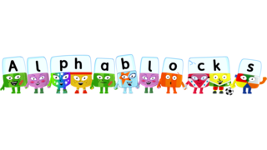
Writing:
Practise your letter formation/ handwriting.
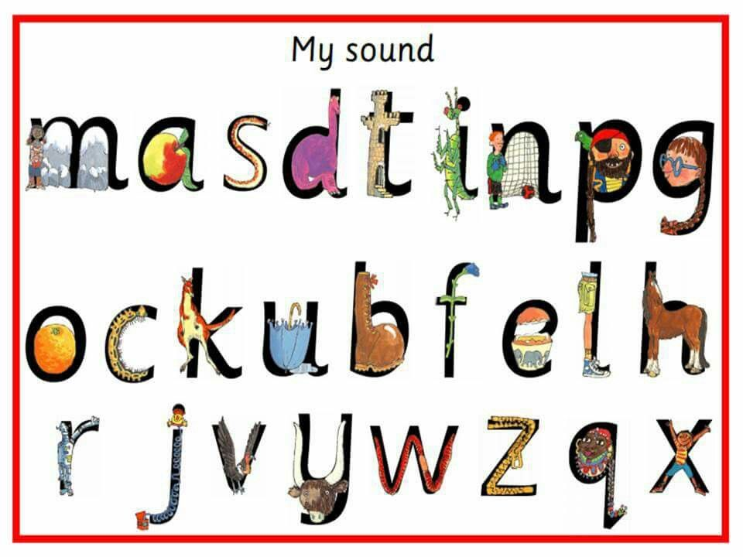
I have also attached a handwriting practise sheet on the class page if you have a printer.

Maths
Can you name these shapes?
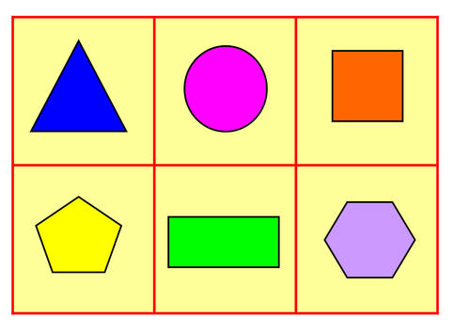
Which one is a…..?
square
circle
pentagon
hexagon
triangle
rectangle
How many sides do they have?
Can you find any of these shapes at home?
Knowledge and Understanding of the World

Make a sun catcher from an old plastic drinks bottle. Colour or paint it and hang it outside.
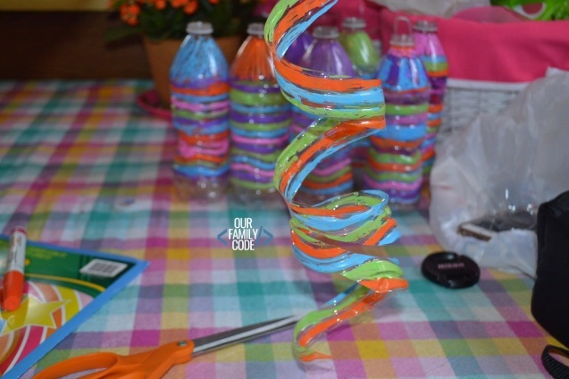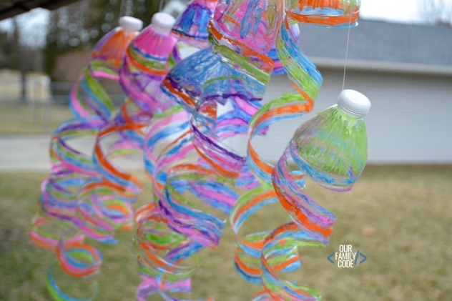
Keep an eye on the weather. I can’t believe we had snow and sleet on Sunday!
Can you make some of your own weather symbols and put one up each day to show what the weather is like?
If you have a printer, you can cut out the ones I have included on the class page.

Please feel free to email me with any photos of art work, pictures of you reading or any home learning you have come up with. My email is on the class page.
Keep in touch
Mrs Golden

