Religious Education:
This term we have been learning about the Easter Story. At the moment
Main Events of the Easter Story

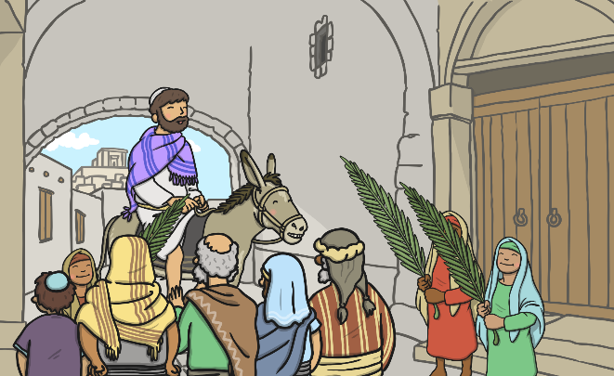

1. Palm Sunday – Jesus arrives in Jerusalem

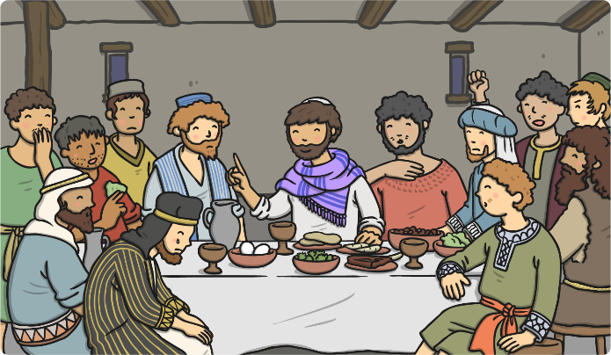

2. Maundy Thursday – The Last Supper

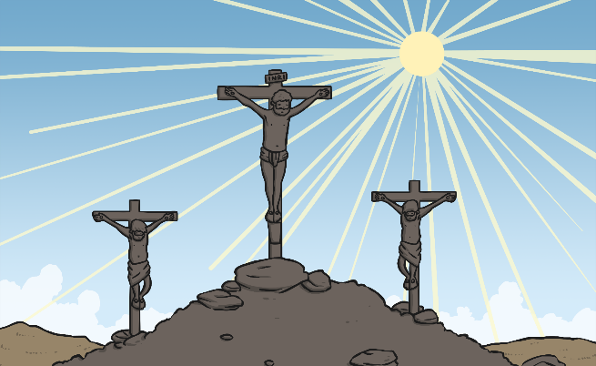

3. Good Friday – Jesus is arrested and Crucified.

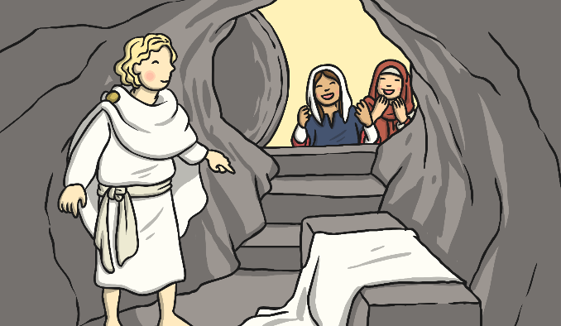

4. Easter Sunday – Jesus rose
again

Activity:
Green – Imagine if you were Mary. Remember Mary is Jesus’ mother. How do you think she would feel at each part of the Easter story? Tell your adult the different feelings she goes through.
Write out the sentences below and finish off these sentence starters in red.
- During Palm Sunday, Jesus was being cheered on and celebrated amongst the people. I felt…

- During Good Friday, Jesus was arrested and forced to carry his cross to be crucified. I felt…

- During Easter Sunday, Jesus rose for the last time. I felt…

Red - Write a diary entry as Mary. Remember, Mary is Jesus’ mother. How do you think she would feel at each part of the Easter story? Tell your adult the different feelings she goes through.
- Write 2 sentences with each of the main events that occur in the Easter Story. The first one is done for you…
Dear Diary,

It has been a glorious day so far. Jesus has been brought through Jerusalem on a donkey. Everyone is cheering for him. I feel like a very proud mother on this Palm Sunday.

Now it’s your go…
- Good Friday.
- Easter Sunday.

Blue - Write a diary entry as Mary. Remember, Mary is Jesus’ mother. How do you think she would feel at each part of the Easter story? Tell your adult the different feelings she goes through.

Dear Diary,

Palm Sunday
- Explain what happened at Palm Sunday.
- How would Mary feel?

Good Friday
- Explain what happened at Palm Sunday.
- How would Mary feel?

Easter Sunday
- Explain what happened at Palm Sunday.
- How would Mary feel?

