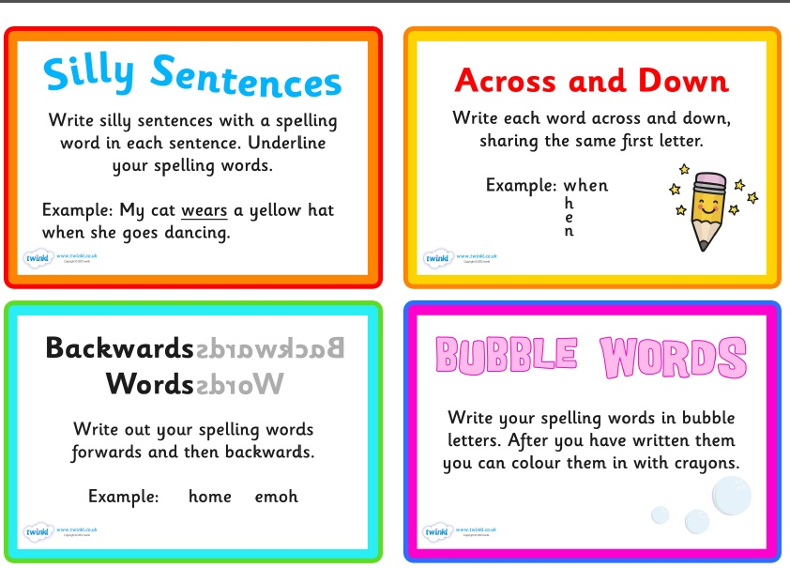
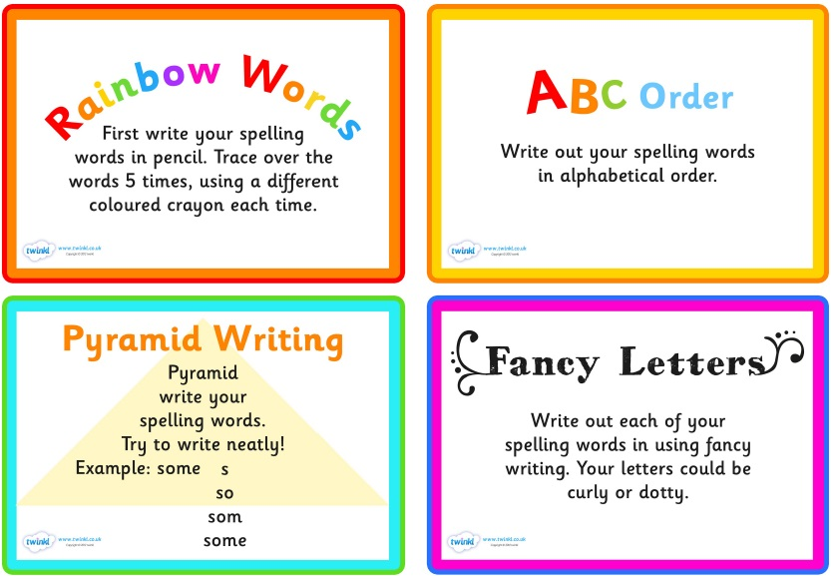
Spellings – Please have a go at these spellings and do a test on Friday. Practise using the ideas below to help you.

Green  because  would  should  with  the  which  where  what  there  their | Red  option  solution  position  relation  introduction  caution  mention  fiction  action  construction | Blue  invention  pollution  hesitation  injection  continuation  completion  attraction  opposition  question  affection

