Squirrels – English (30.03.20)

**Year 2**

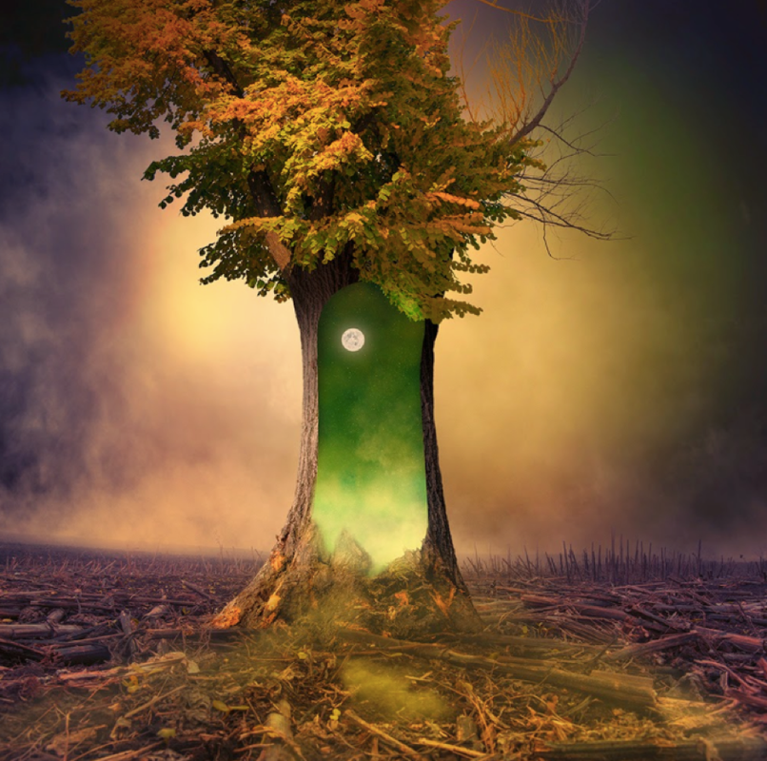

Look at this tree. When I saw this, I had so many thoughts in my mind.

Mrs Siddiqui is totally confused!



Can you help by answering my questions below? Remember we are all fantastic writers who have super imagination! Let is loose!!!

**Question time!**

What do you think has caused the destruction all around the tree?

Why has this one tree survived? Is there a portal right in the middle?

If you walked through the portal, what would happen to you? What would you see?

If this portal to another world, would you go through it or stay on Earth, even if you had no idea what could happen?

Is it good to take risks? Are some risks riskier than others?

**Year 1**