SQUIRRELS - ENGLISH

Year 2
Continuing with our topic Where the Wild Things Are, let us look at the Gruffalo. Can you write a character description of the Gruffalo in your own words?
Remember to describe its appearance and personality using lots of adjectives. Some ideas have been given to help you make a start.
Here is a link if you have forgotten the story.
https://www.youtube.com/watch?v=s8sUPpPc8Ws

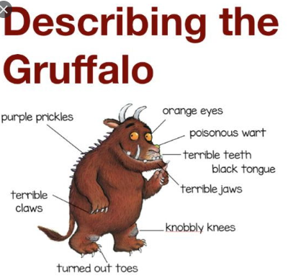
Challenge
- Can you use similes? (as prickly as a …)
- Can you use expanded noun phrases? (purple, pointy prickles)

Year 1

Can you use the following words in a sentence?

I _____________________________________________________

was ____________________________________________________

the_____________________________________________________

to______________________________________________________

my_____________________________________________________

Please refer to Read Write Inc support document for any help.

Challenge

Read any story book from home. Or use the link below.

https://www.youtube.com/watch?v=s8sUPpPc8Ws

Create a story map. Can you now retell the story using your plan in your own words? Can you use some conjunctions (and, but, because) to extend your sentences?

