**Year 1 - Maths**

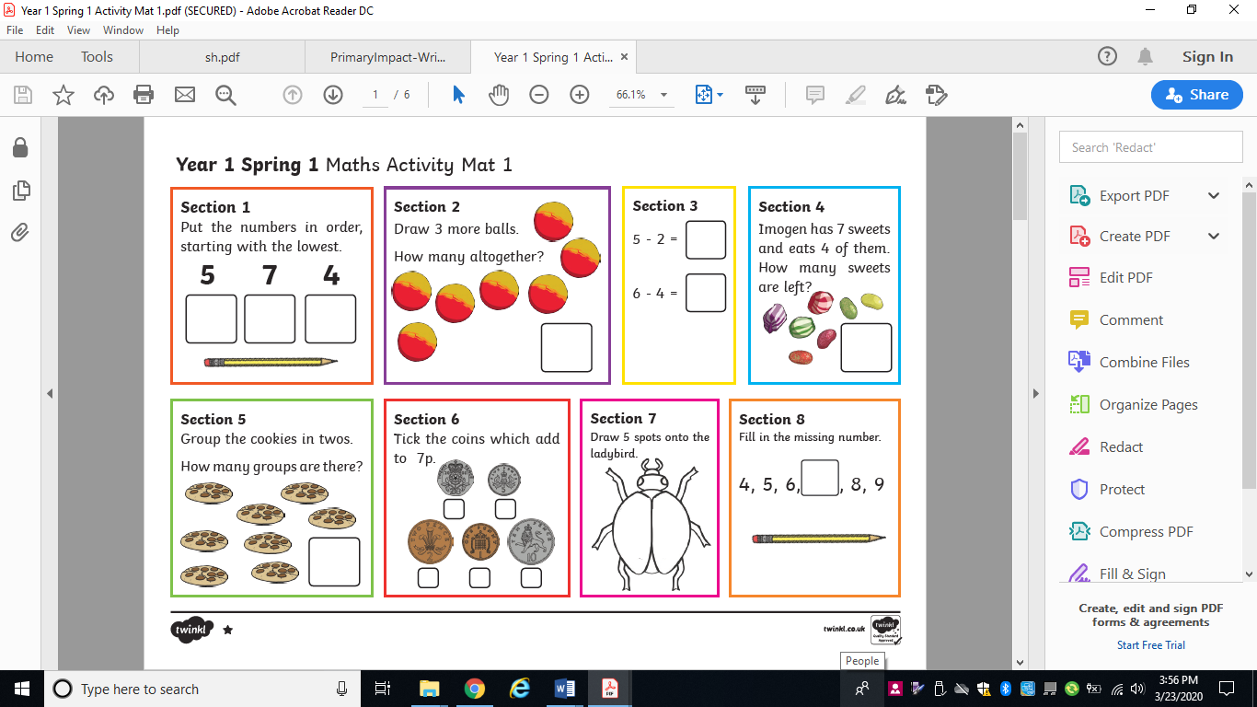

**Year 1- Challenge 1**

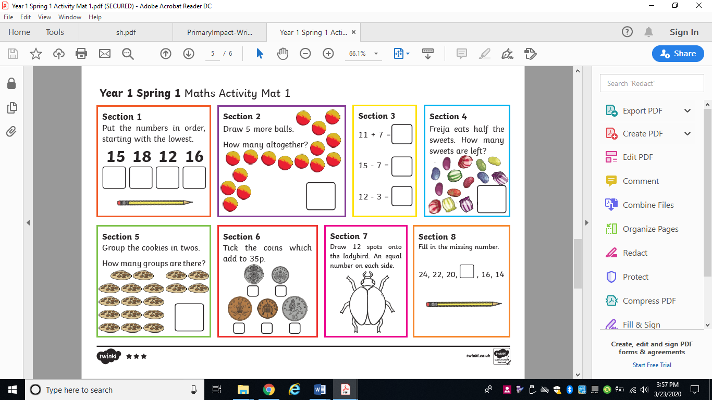

**Year 1 - Challenge 2**



**Year 2 - Maths**





** **





