Squirrels Maths (30.03.20)
Year 2
I would like you to do a little survey for me today. Go around your house and ask each member of your family a question. “How many fruits do you eat each week?”
Now enter the information in the table below.
Name | Number of fruits eaten each week

Now can you draw a bar graph using this information.

Here is an example of a bar graph showing gold stars earned by children in a family.
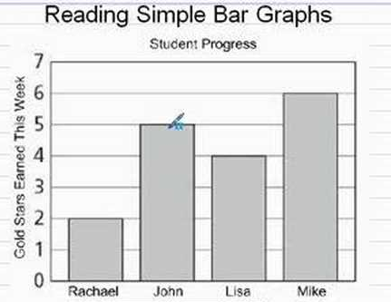

Year 1
Play these games today! Remember to use your addition and subtraction knowledge.
https://uk.ixl.com/math/year-1/add-with-pictures-sums-up-to-20
https://uk.ixl.com/math/year-1/subtract-with-pictures-numbers-up-to-20

Challenge
https://uk.ixl.com/math/year-1/complete-the-addition-sentence-sums-up-to-10

