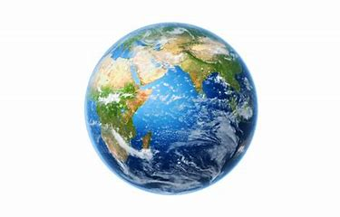
Topic- Geography
In Geography we have been comparing non-European countries to the UK. We have looked at Cambodia in Asia.
Can you pick another non-European country to research? Maybe one with family links or that interests you. In class we have discussed physical features of places, these are natural (hills, rivers, beaches, rainforests, weather) and human features which are man-made (towns, villages, roads, shops, factories). Please pick a country and find out about it.
Next week you can create either a poster, piece of writing, labelled picture, Word document or Powerpoint with what you have found out. This week please research and find out information.
These websites may be helpful…
https://www.atozkidsstuff.com/world.html
https://www.natgeokids.com/uk/teacher-category/places/

