Art: This term we are learning about Fairytales and how they have changed over time.
Activity:
Please design a castle that you will be able to make out of junk modelling.
Ask your parents if you are able to use the empty boxes from food packaging.

To think about when you are designing:
- What do castles have?
- What materials do you have?
- What resources will you need to put it together?

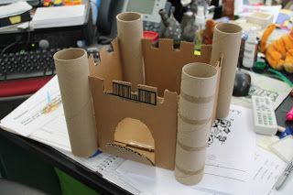
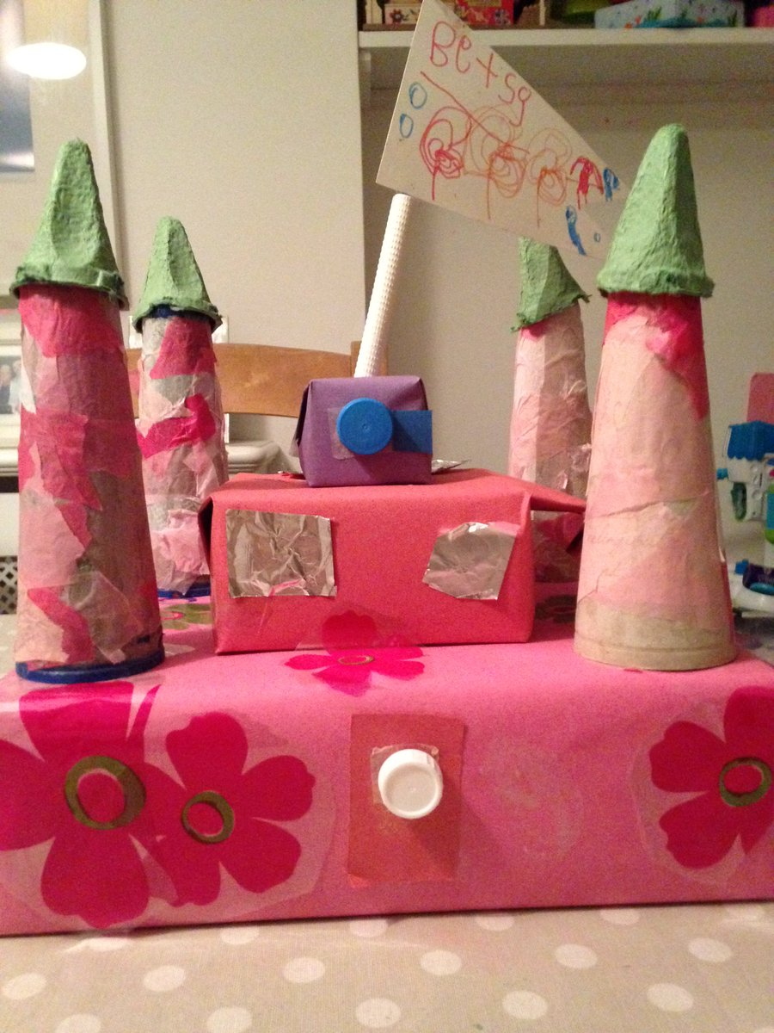
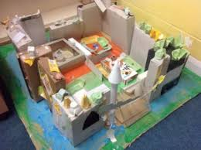
Here are some examples:

