29.4 - Last week you drew a tessellation pattern using regular shapes.
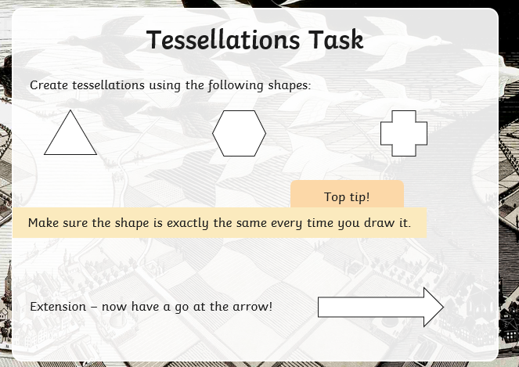

Go to the following website: watch the video
https://www.bbc.co.uk/bitesize/topics/zjv39j6/articles/zgxwfcw

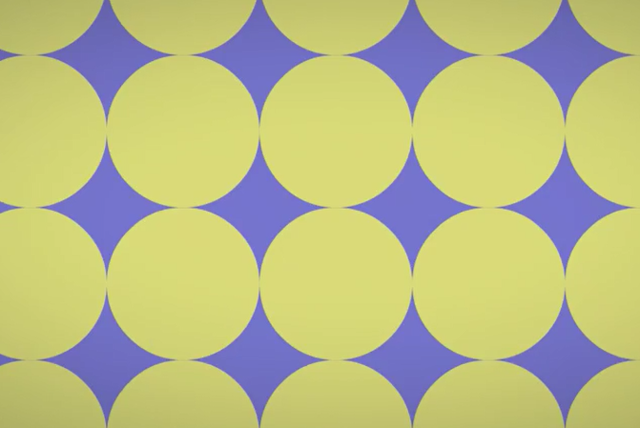

Create your own irregular tessellation pattern. Here are some examples.
