Computing
Last week you played on the Beebot App. When you put in instructions for the Beebots you were creating ‘algorithms.’
This week I would like you to ‘debug’ my instructions. ‘Debug’ means to work out what I have done wrong and correct it.

Garden Level 3
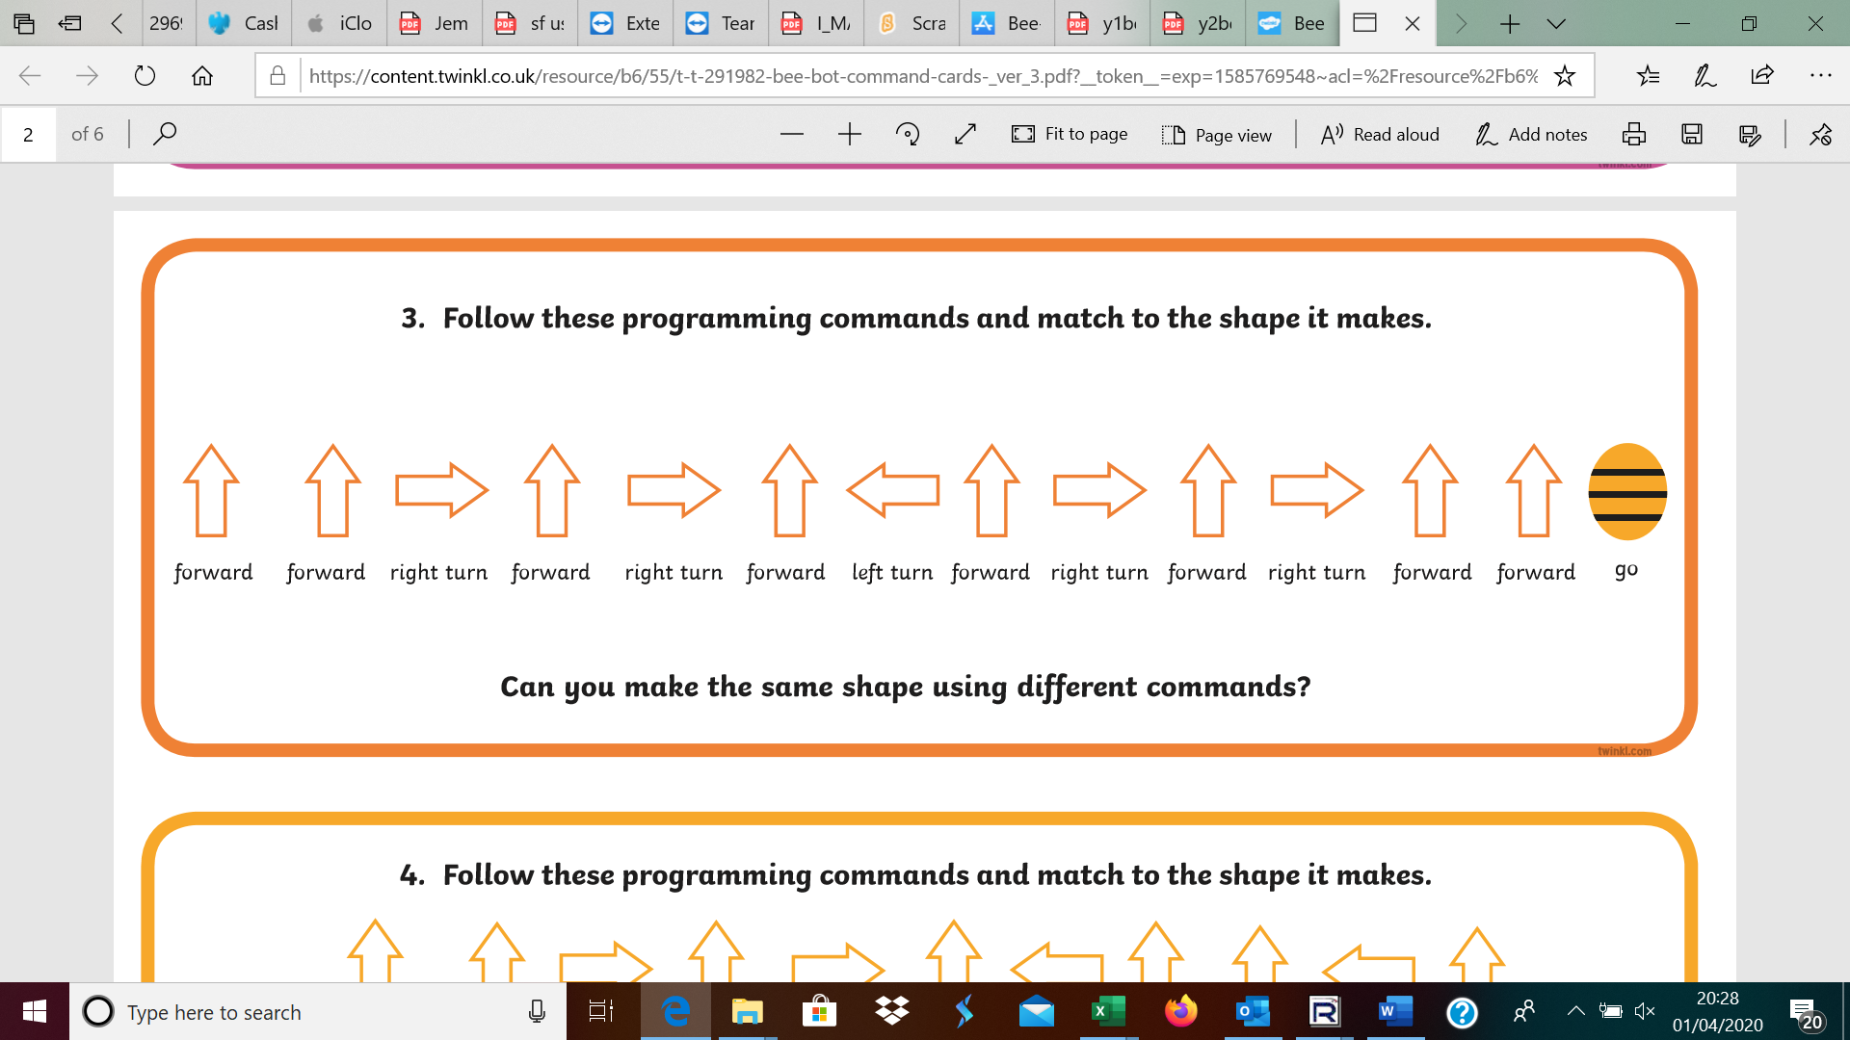

Garden Level 4

Garden Level 5

Challenge- Can you write instructions down and make one mistake on purpose so an adult/older sibling can correct it for you?

