1.04.2020
English – Have a go at these reading comprehensions.
Newspaper Article: The Green, Red, Blue questions are below.
The Oracle
The newspaper that seeks the truth! |  | XVIII July LXIV AD
Burning Hatred
Who is to blame for this terrible crime?
1. The mighty city of Rome is in chaos tonight as an out of control fire sweeps across the city. Citizens have been forced to flee their burning homes, as buildings collapse and businesses are ruined. Fanned by strong winds, the raging inferno quickly devoured whole sections of this wonderful city as flames like living devils leapt from building to building. People are fighting a losing battle, with some officials claiming this could be the end of Rome as we know it!  2. ‘We were just bathing when we heard the terrible sound of a nearby building collapsing accompanied by horrendous screams!’ one citizen tells us. ‘There was suddenly choking smoke. My poor wife burnt her arm and my brother is still missing. Someone said it was the Christians. Those Christians have a lot to answer for!’  3. But Octavia Lucida, an 11-year-old, claims she was an eyewitness to the beginning of this terrifying event. She was one of the lucky ones to have escaped the fire. | 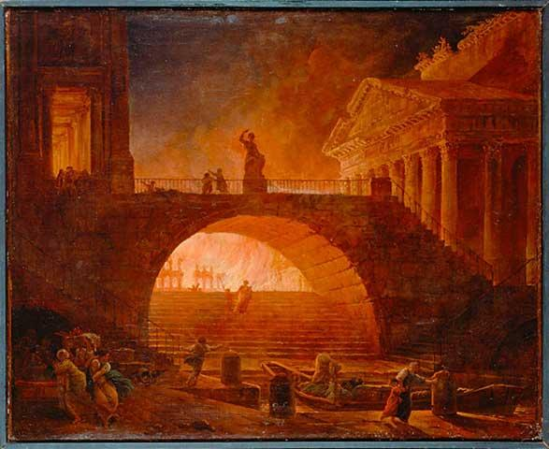
4. She went on to tell us how she saw a suspicious-looking fellow behind the Circus Maximus – the main chariot racing station. She was with her younger brother Tacitus near the shop. A fellow wearing a red cloak, with a wicked, single glittering eye and an eye-patch, had started a fire in the doorway. He was then seen to run away with a grin on his face. ‘The Christians have set my shop alight!’ she heard him cry.

5. But minutes later, the shop owner himself came around the corner, only to see his livelihood go up in smoke.

6. This is beginning to look more like a hate crime to us at The Oracle. Will these poor Christians ever
be accepted in our usually tolerant city?

Green/Red: Get your adult to read through the article and follow what they are reading to answer the questions.
1. What is the title of this Newspaper article?
2. Paragraph 1 - What has happened to Rome?
3. Paragraph 2. What was the citizen doing when Rome was set on fire?
4. Paragraph 4 - Where was Octavia with her brother?
5. Paragraph 4 - What was the stranger wearing?
6. Paragraph 6 – What type of crime is this?

Blue
- How did the citizen who was bathing know that something was wrong?
Give two ways that he knew.

- What type of persuasive punctuation is used in the subheading ‘Who is to blame for this terrible crime?’

- What has happened to Rome?

- What was the citizen doing when Rome was set on fire?

- What was the stranger wearing – Write down the description.

- What is the name of the newspaper?

