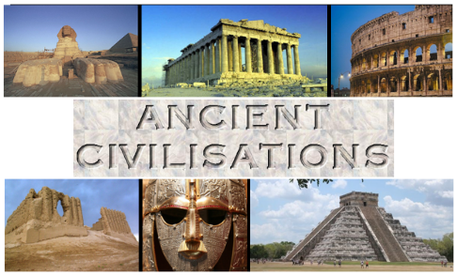

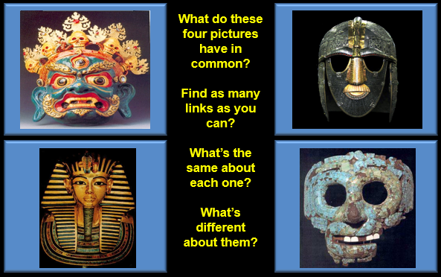

Go to the following website
https://kids.britannica.com/students/article/ancient-civilization/272856
Ancient Egypt
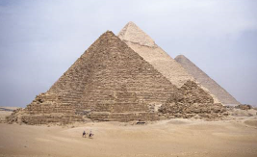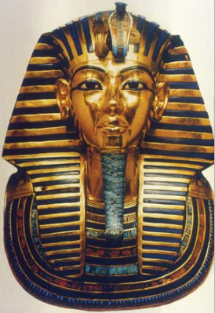

What can you find out about pyramids and Pharaohs?
Create your own fact file or power point if you are able; include information about:
- When did the civilisation roughly start?
- Why was the Nile important?
- Who was king Menes?
- What are Hieroglyphics?

Good luck. Email me your finished version if you can.

