1.04.2020
Maths – Calculating the perimeter of 2D shapes.
Perimeter - https://www.bbc.co.uk/bitesize/topics/zvmxsbk/articles/zsr4k7h
- The perimeter is the length of the shape. Just add up all the sides and there is the answer.
The answer:
10 + 10 + 10 + 10 = 40 cm.
- Have a go at the questions below.
Green
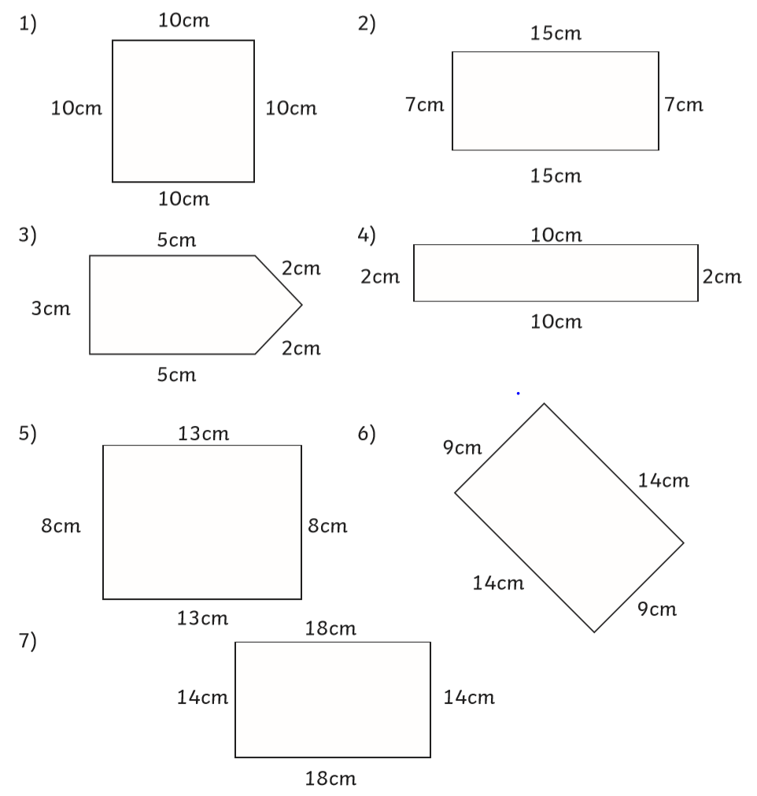

Red/Blue
Perimeter – You may notice that some of the shapes don’t have all the sides labelled. Use your knowledge of shape to see if you can work them out. One has been done for you.
Answer: A rectangle has 2 long edges and 2 short edges that are equal.
23 + 23 + 12 + 12 = 70m

