Maths: Adding Fractions

Green / Red

[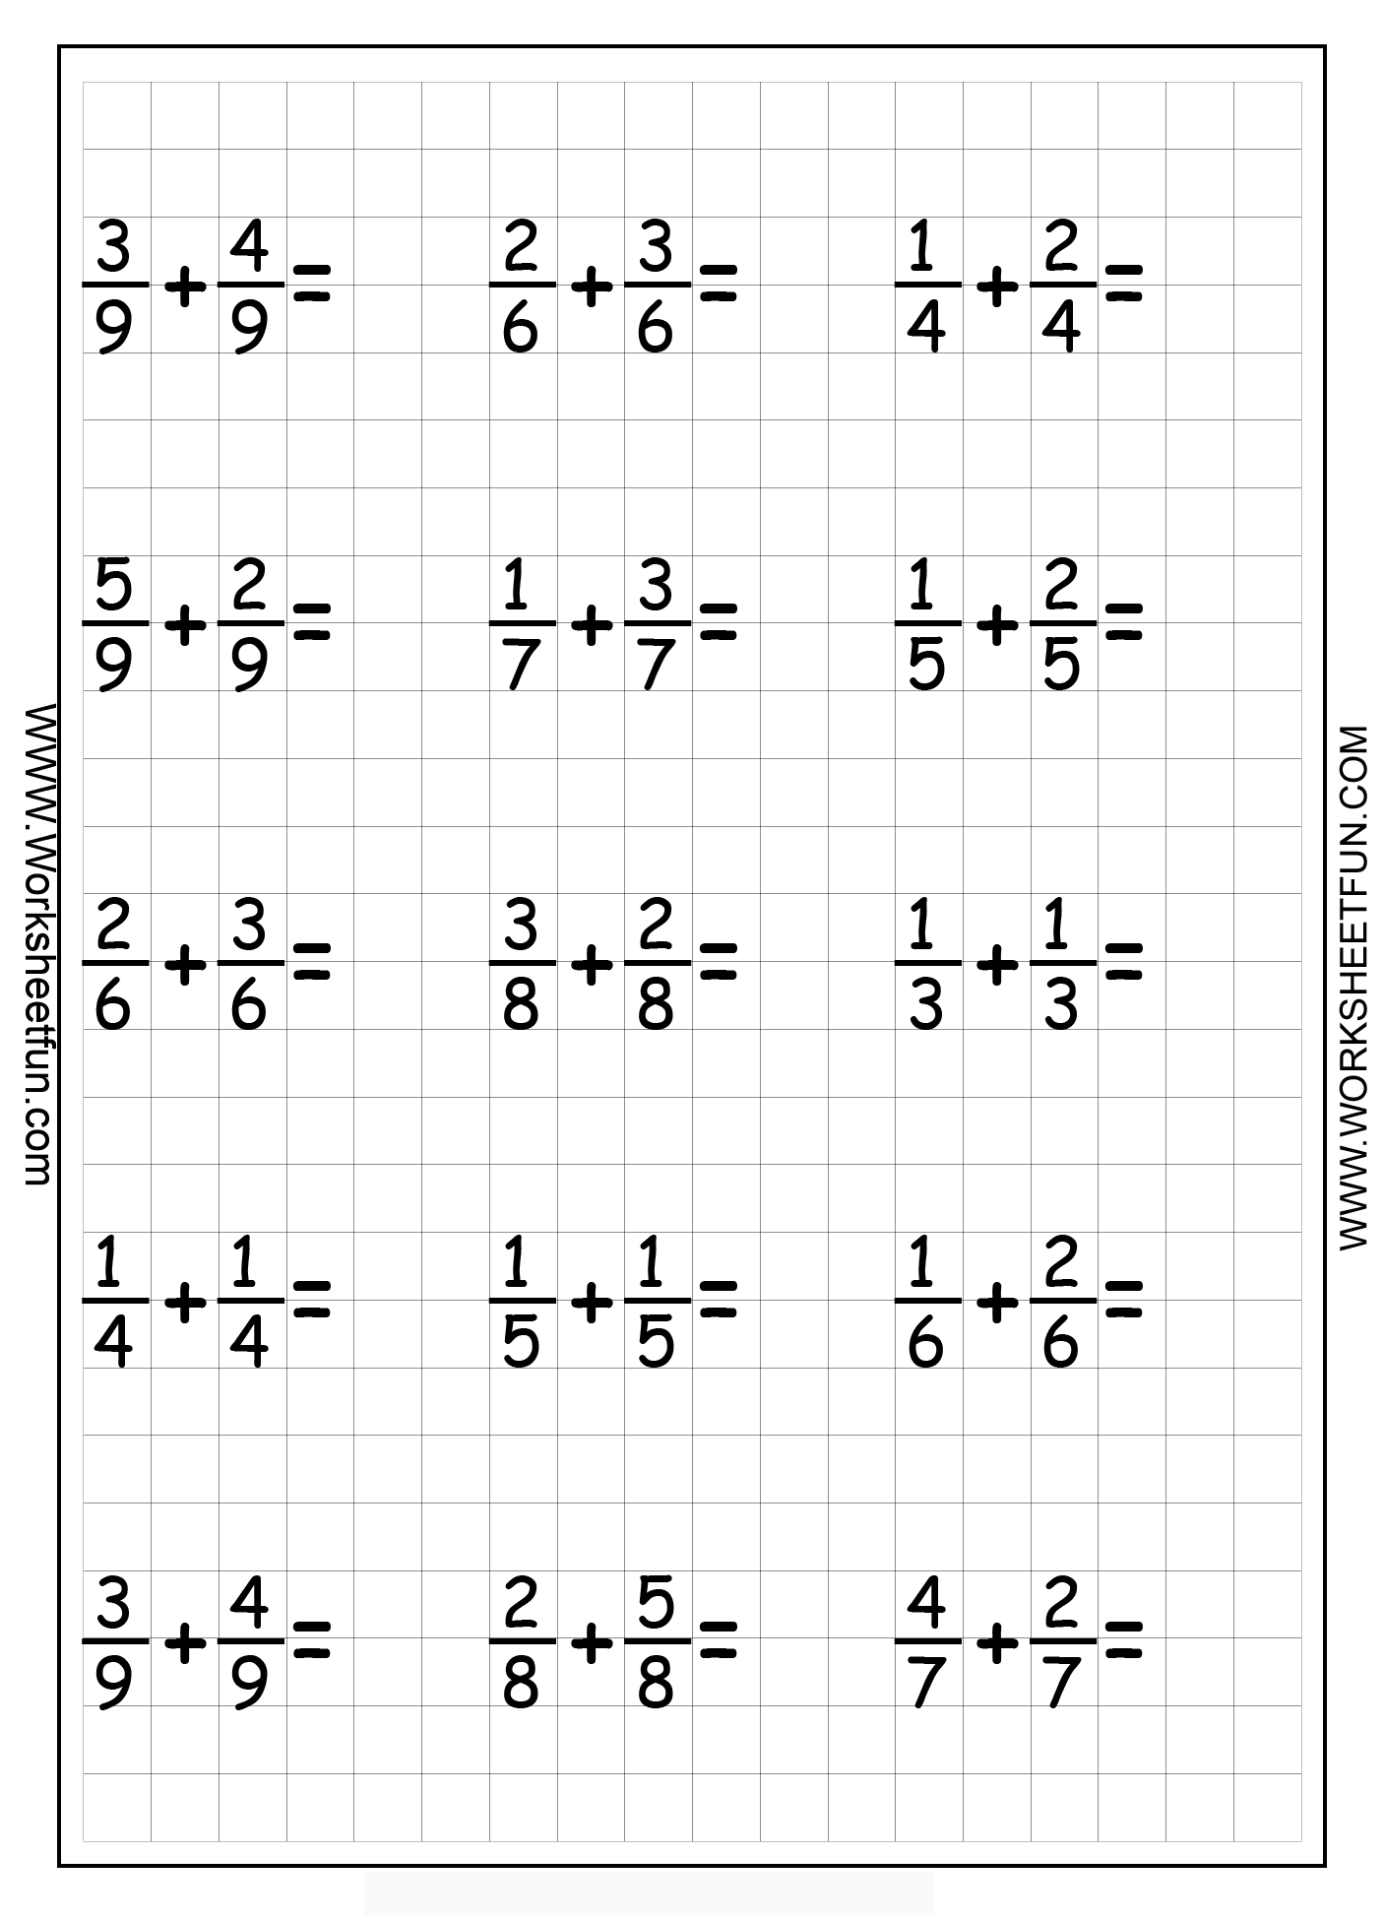](https://www.google.co.uk/url?sa=i&url=https%3A%2F%2Fwww.pinterest.com%2Fpin%2F400327854349908823%2F&psig=AOvVaw0BXOQf0ALvsb8Qq2rTC5T_&ust=1587394025214000&source=images&cd=vfe&ved=0CAIQjRxqFwoTCOiAi93d9OgCFQAAAAAdAAAAABAD)

Blue

[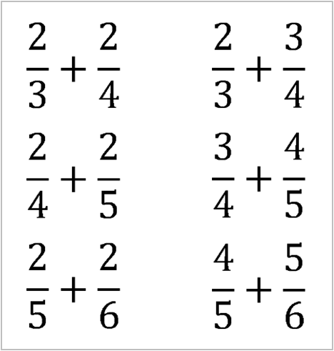](https://www.google.co.uk/url?sa=i&url=http%3A%2F%2Fwww.inquirymaths.com%2Fhome%2Fnumber-prompts%2Fadding-fractions-inquiry&psig=AOvVaw11W8xBo054tA2a5_ACZoqF&ust=1587394130049000&source=images&cd=vfe&ved=0CAIQjRxqFwoTCPDStJDe9OgCFQAAAAAdAAAAABAb)