Year 4 Maths: Lesson 3
Hello Everyone,
I hope that you are all well and keeping safe. Here is how to access ‘Lesson 3’ of Fractions.
- Please click on this link: https://whiterosemaths.com/homelearning/year-4/

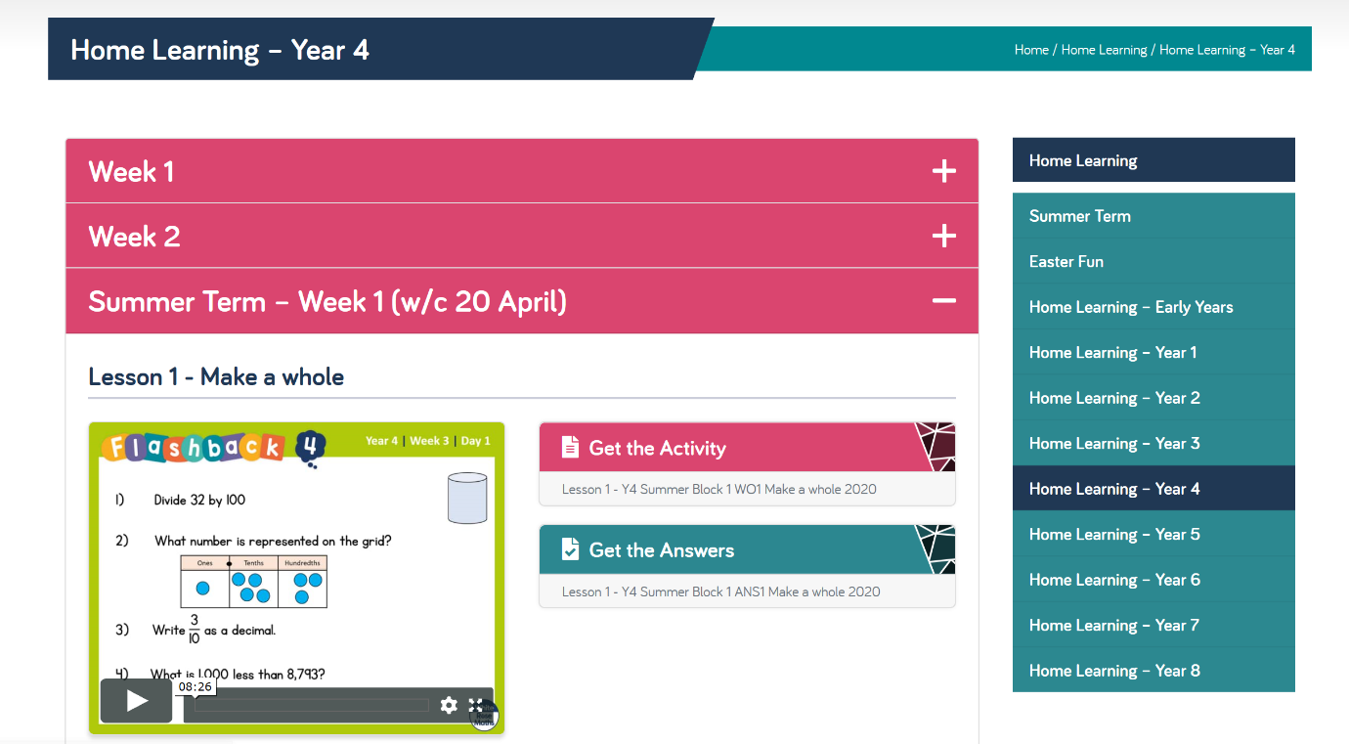
- You will come to a page that looks like this:

- Please click on ‘Week 1’

- Then once you have done this, scroll down until you get to ‘Lesson 3.’
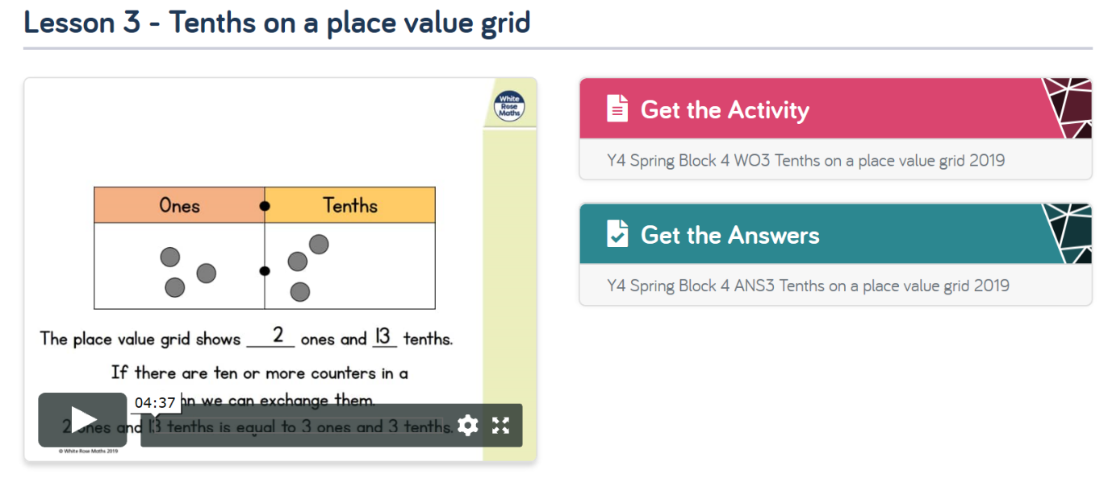

- Please watch the video on the left to help with your knowledge and then press ‘Get the Activity.’

- There is a video on the ‘Foxes Class Page’ showing how to answer the questions online if you are not able to print it.

- Otherwise, you are more than welcome to answer the questions on scrap paper using the worksheet on the screen.

