Summer week 1
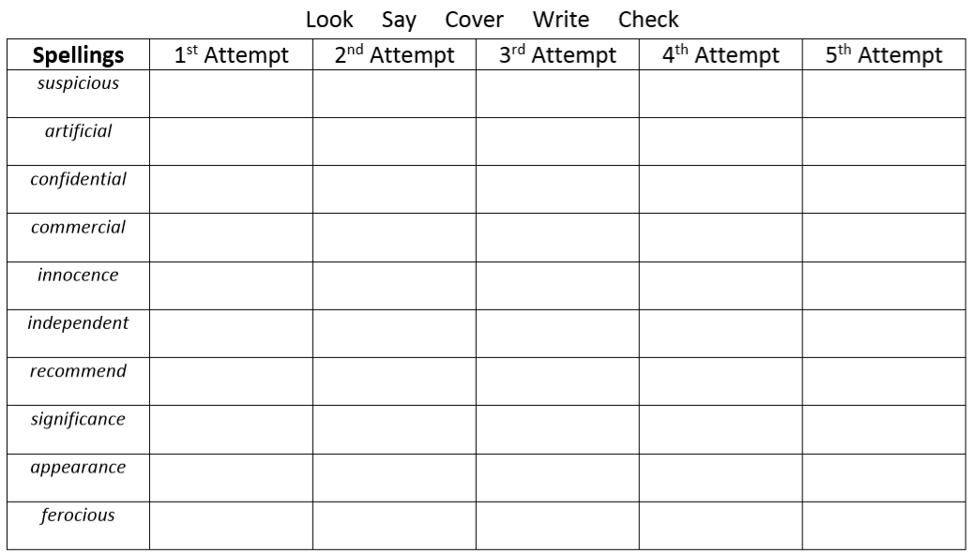
Write sentences using these words correctly. Use a dictionary to help.

