Summer week 1
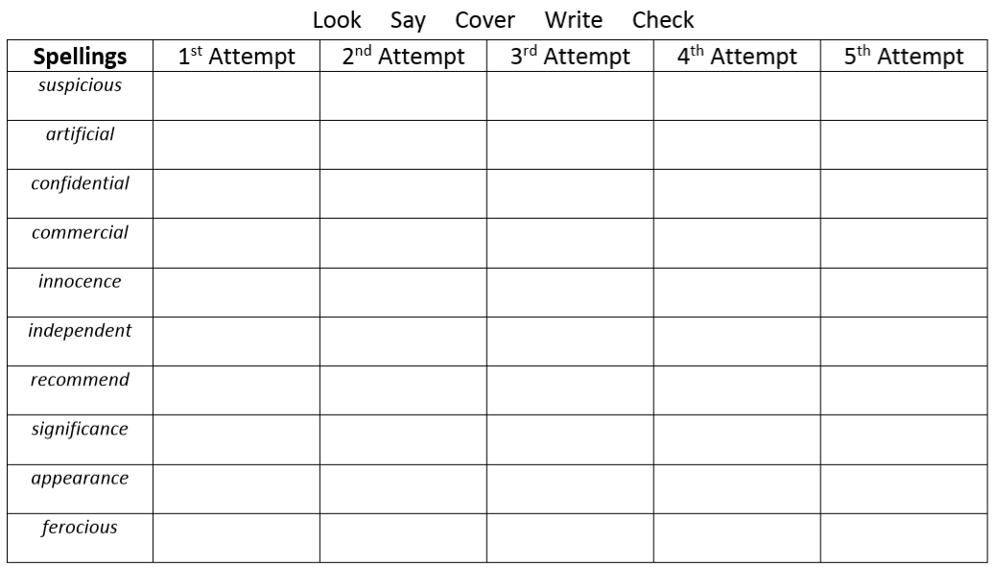
Can you spot the spelling patterns?

