LQ: How do mosque buildings express Islamic beliefs and values?

Should art be less important
than giving to charity?

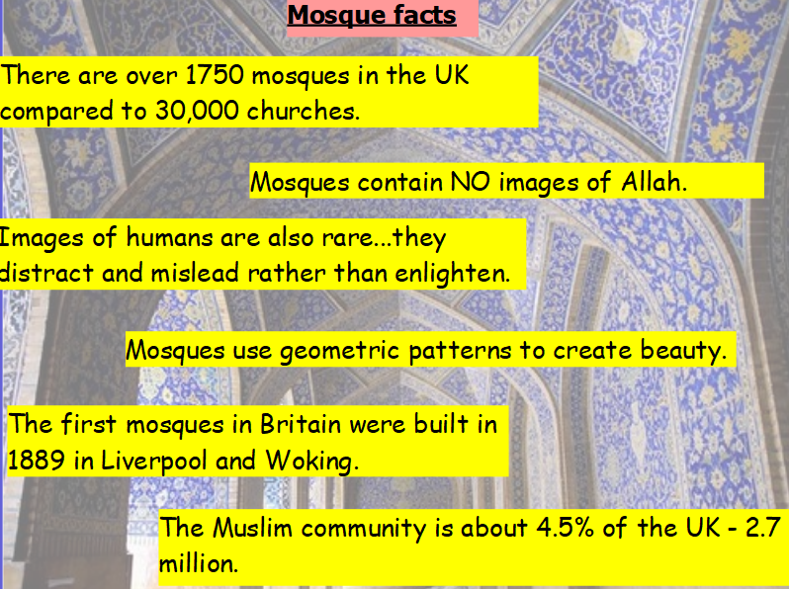

Activity 1
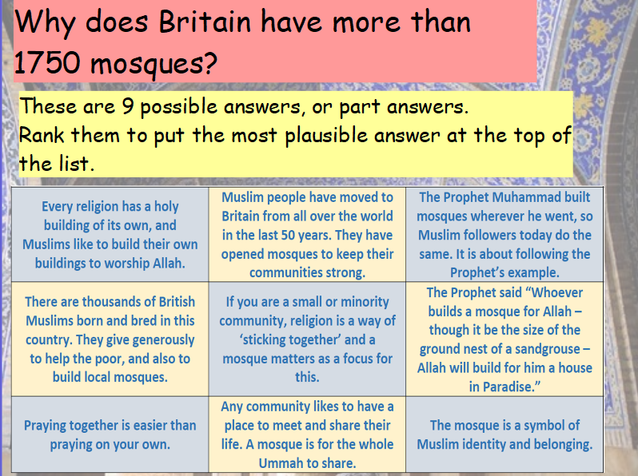

Activity 2
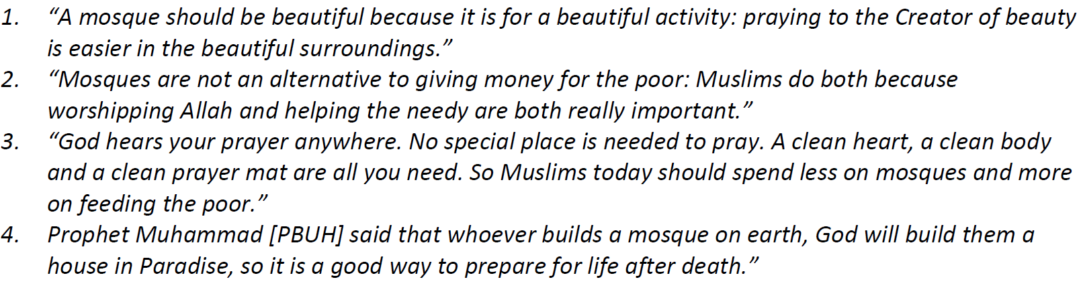
Which of these ideas do you think is the best?
Write down your thought on each of these statements

