RE
Please read the following pages to find out how Christians celebrate and remember Palm Sunday, Good Friday and Easter Sunday. Also this video shows how Easter is celebrated in Church and some other Easter traditions and games. https://www.youtube.com/watch?v=StlJgYF-Ki8
(Google ‘Let’s celebrate Easter’ Cbeebies video)
Can you decorate the egg with images to show all the different things Christians do over the Easter period?
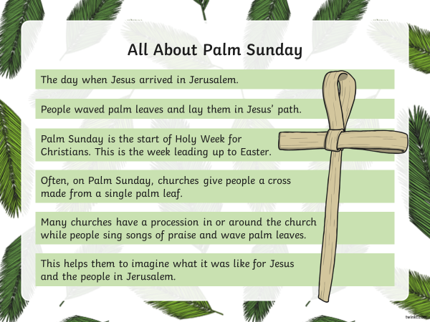
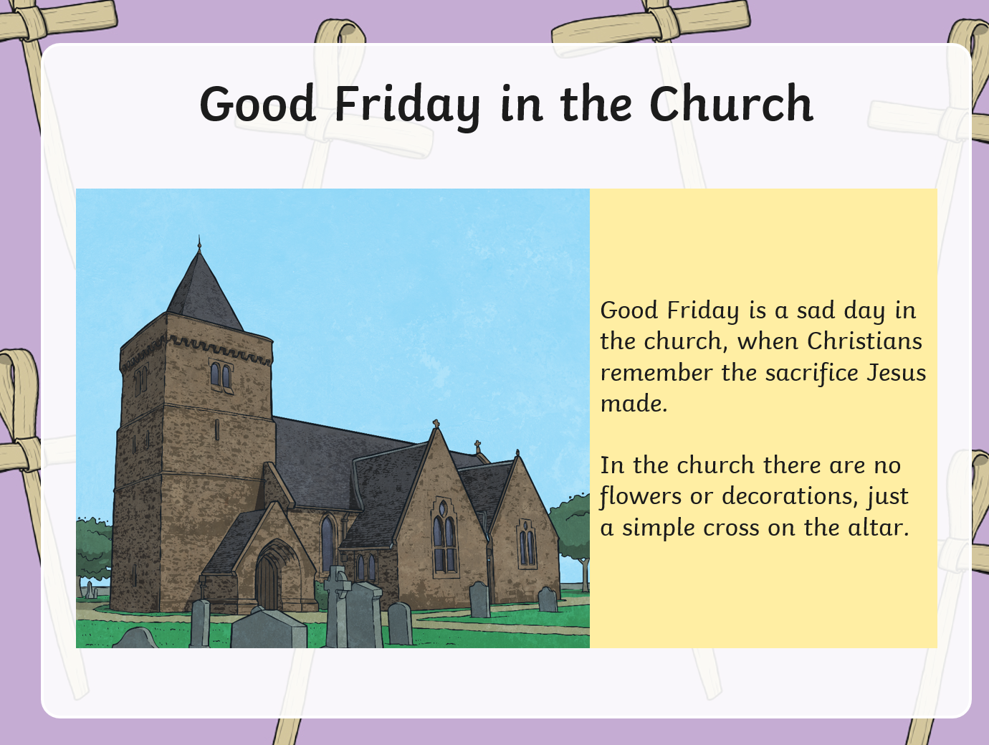
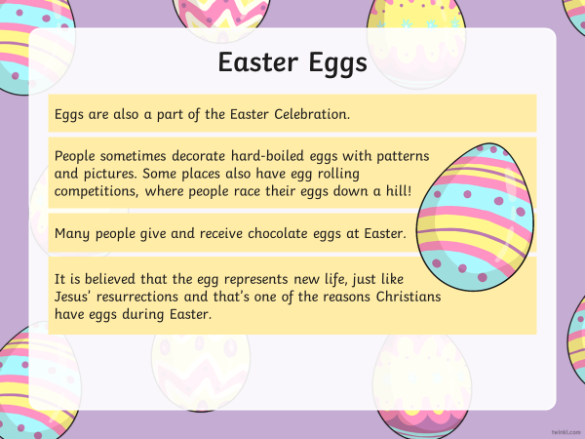
Can you decorate the egg with images to show all the different things Christians do over the Easter period?

