Rabbits Home Learning 22.4.20

Reading:
Find somewhere new to read every day, you could go under your bed, behind the sofa, in the garden….
https://www.bbc.co.uk/iplayer/episodes/b00jdlm2/cbeebies-bedtime-stories
Choose a story to listen to, there are lots to listen to.
Ask your Mum or Dad to choose their favourite too!
Draw a picture of your favourite.
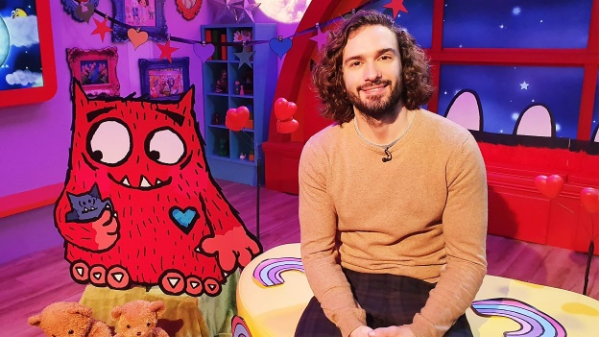
I like this one!

Writing:
Write some sentences about what you can see.
Start each sentence with
I can see…….

Maths
Watch and sing along and exercise with the Spiderman counting song.
https://www.youtube.com/watch?v=L9md4L2pAVQ

Money
This week we are going to look at different coins.
Sing along to the money song.
https://www.youtube.com/watch?v=dFzAU3u06Ps
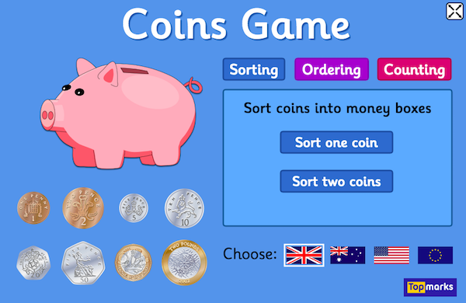
Try this game at home, start with the sorting activity.
https://www.topmarks.co.uk/money/coins-game

Knowledge and understanding of the world

Can you find out where some of your food comes from?
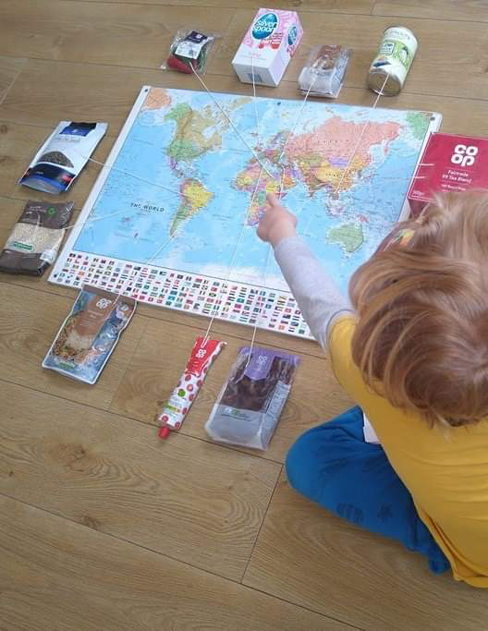

If you haven’t got a map, find one on your tablet or computer.

