Rabbits Home Learning 27.4.20

Reading:
https://www.phonicsplay.co.uk/freeIndex.htm#
Try this website for phonics practise. Start with phase 1 and go onto phase 2 if you find it easy.
Ask someone in your family to read you a story. It can be one of your favourites or a story online.
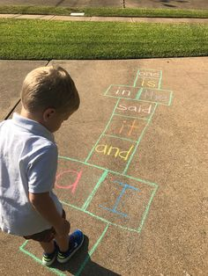
Try the tricky words song
https://www.youtube.com/watch?v=TvMyssfAUx0
Ask a grown up to make you a hopscotch using the words.

Writing:
Can you make a story map using the story you listened to?
Or use this story…. Don’t forget to add words to your map if you can.
https://www.youtube.com/watch?v=75NQK-Sm1YY&t=4s
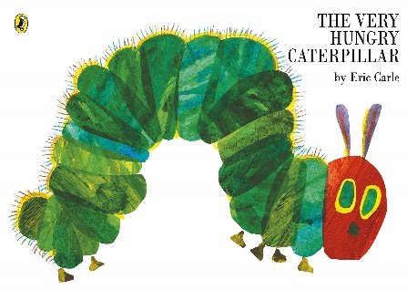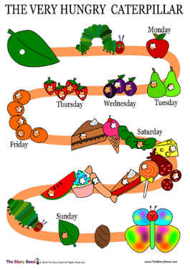
Maths
Find lots of different socks in your house. Can you order them by length? Whose socks are the longest? Can you take a photo and send it to me?

Knowledge and understanding of the world
When you go out for your walk, try and spot three different types of trees. Take photos of them and find out what they are called.
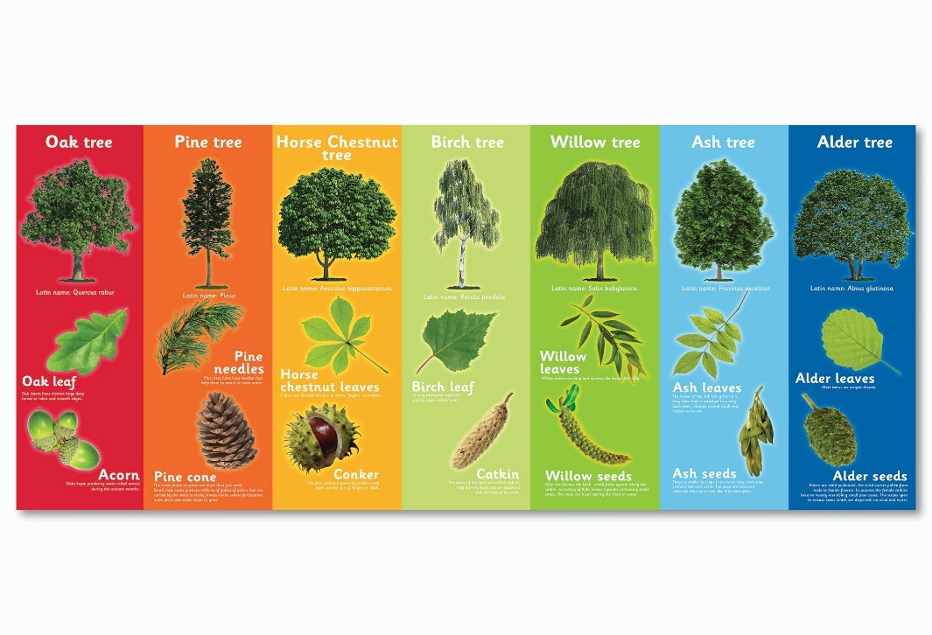
Draw a picture of them.
Make binoculars out of toilet roll tubes. Play ‘I Spy’ looking for birds and nature out of your window.
