Rabbits Home Learning 6 1.4.20

Reading:
Read one of your books or one of the reading sheets you were given.

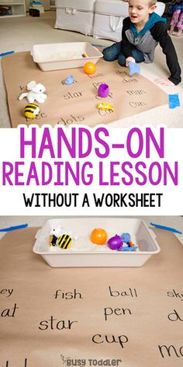
Ask Mum or Dad to help you set this up in the house or in the garden if you have chalks.
The words can be written on pieces of paper and hidden around the house rather than on one sheet. Then go on a word hunt!
Keep some of the words to 3 letter words but if you need an extra challenge ask your grown up to write some words with ‘special friends’.

…. And just for fun, watch an episode of ‘Sarah and Duck’. I know how much you all loved watching it at school!
https://www.bbc.co.uk/iplayer/episodes/b04drklx/sarah-duck
Writing:
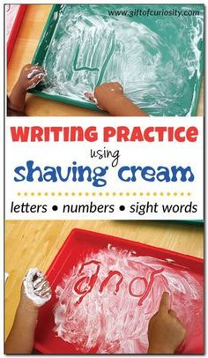
If you don’t have shaving foam, or enough to spare, try making a mud mixture, squirty cream or bubbles with washing up liquid or flour.
I know some of these things are in short supply and please don’t make a special trip to a shop.
If you can’t do this activity, please practise your handwriting using any pens or pencils you have.
Try these words: and, the, he, she, me, we, you and then try lots of numbers.

Maths
Watch and sing along with the shapes song.
https://www.youtube.com/watch?v=Umu58RxNL7I

Try this shape spotter game at home.
Move the shape (the spy hole) in the centre around to see if you can recognise the 2D shape. You can make the spy hole bigger or smaller
https://www.ictgames.com/mobilePage/shiftingShapes/index.html

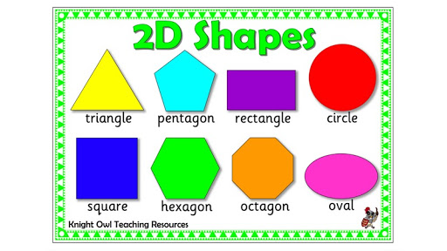
If you would like a challenge, try drawing some shapes or making some shapes in the garden using sticks or something else you can find in the house or outside.
What could you use to make a circle?

Physical development
https://www.bbc.co.uk/iplayer/episode/p06tmn51/andys-wild-workouts-series-1-1-under-the-sea
Join in with Andy’s wild workouts

Please feel free to email me with any photos of art work, pictures of you reading or any home learning you have come up with. My email is on the class page.
Keep in touch
Mrs Golden

