Rabbits Home Learning 7 3.4.20

Reading:
If you register on line you can get free access to the e books online which are fantastic for all ages and abilities. Oxford owl is what we use for RWI (Read Write Inc).
https://www.oxfordowl.co.uk/for-home/find-a-book/library-page/
Writing:
Use your purplemash log in.
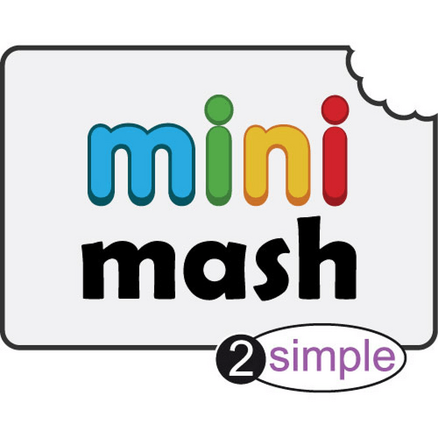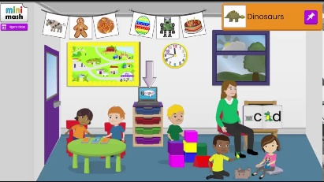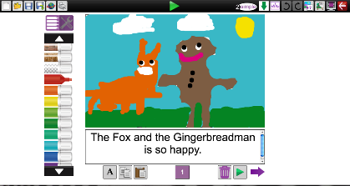
Go to ‘Mini mash’ and click on ‘enter mini mash’.
Click on the teacher ‘Reading and writing’ and try and make your own story or use one you have at home or a story we have read at school. Ask Mum or Dad to help you with the writing bit.

Maths
Watch and sing along with the shapes song.
https://www.youtube.com/watch?v=Umu58RxNL7I
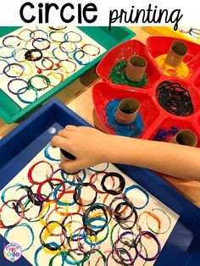
If you don’t have any paint, try drawing around the toilet roll tube as many times as you can in different colours.
You could try making the end of the toilet roll into a square, a triangle or another 2D shape and mixing up the shapes in your picture.

Knowledge and Understanding of the World
Go on a scavenger hunt in the house or garden.
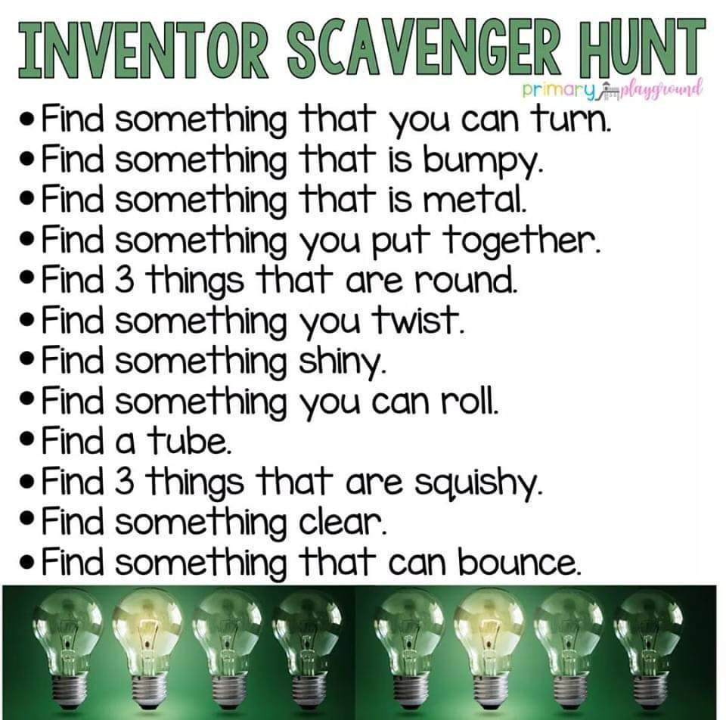

Understanding Christianity/ Creative learning
https://www.youtube.com/watch?v=Wnbo2AmS3OI
Watch this story about Easter and Jesus. Maybe you could make a picture about Jesus and his friend Mary. Or a picture of a cross to remind us about Easter.
Please feel free to email me with any photos of things your son or daughter has been doing. My email is on the class page.
Have a lovely 2 weeks with your families.
Stay safe.
Mrs Golden
xxxx
