Rabbits Home Learning 20.4.20
Welcome back!
Reading:
There are loads of new ebooks online at Oxford Owl which we use for RWI.
https://www.oxfordowl.co.uk/for-home/find-a-book/library-page/?view=image&query=&type=book&age_group=&level=&level_select=&book_type=&series=Read+Write+Inc.#
Check out the link above. Choose either a ‘sound blending’ book or one of the ‘Red Ditties’ depending on how confident you feel.

Writing:
Practise your letter formation.
Ask a grown up to carefully write some words for you… can you copy them or make them disappear like in the picture below?
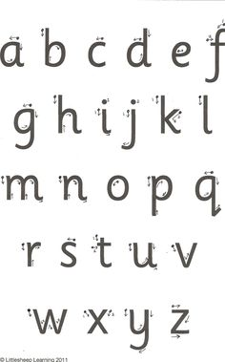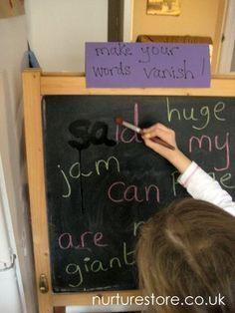

Maths
Watch and sing along and exercise with the Spiderman counting song.
https://www.youtube.com/watch?v=L9md4L2pAVQ

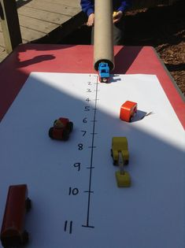
Make a number line and roll cars or other toys to see which one goes the furthest.
Make your line go up to 10 or even 20.

Make or draw a picture
Use your purplemash log in.

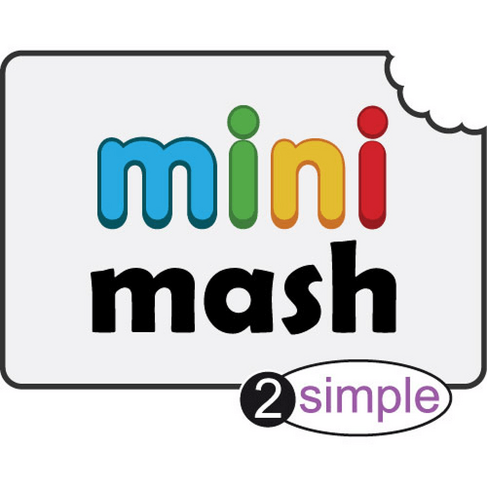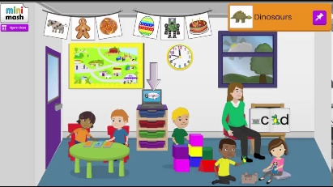
Go ‘outside’ by clicking on the door and then choose drawing and painting.
Have a go at making your own picture. You can use some of the background or make your own.
If you can’t access purple mash draw a swirly line across a piece of paper lots of times making shapes and patterns.
Colour in the different shapes you have made.

