Rabbits Home Learning 22.4.20

Reading:
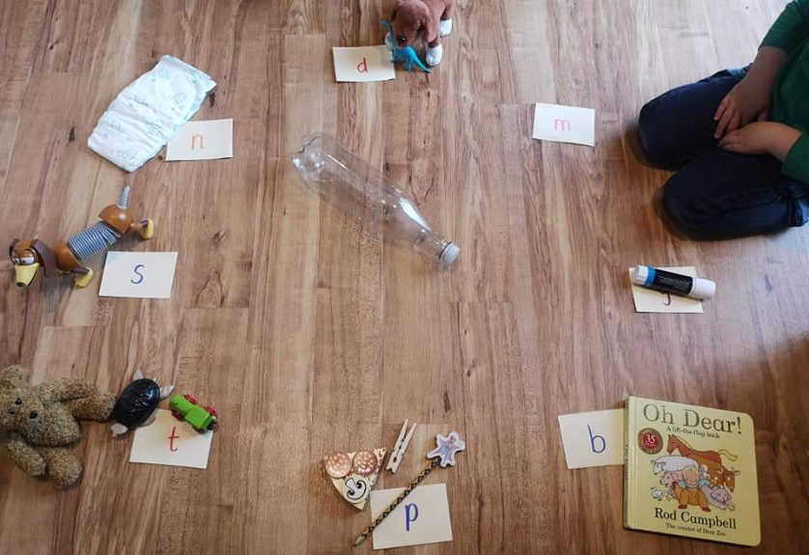
Play a game of phonics spin the bottle.
If you want a challenge, try using
sh th ch
For those of you who were in the Y1/YR RWI group, can you remember these sounds…?
ay ee igh ow

Writing:
Please have a look at the ‘writing words’ document attached for today on the website.
Have a go at writing the words in a book, on paper or anything you have at home.
(Parents: the words are.. sun, ant, bag, cat, fox, jam, ship, chick, queen, play, feet, sheep)

sun 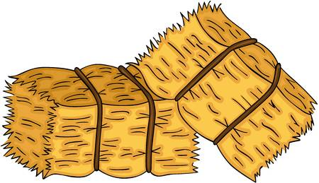 hay

Maths
Watch and sing along and exercise with the Spiderman counting song.
https://www.youtube.com/watch?v=L9md4L2pAVQ
Money
This week we are going to look at different coins.
Sing along to the money song.
https://www.youtube.com/watch?v=dFzAU3u06Ps
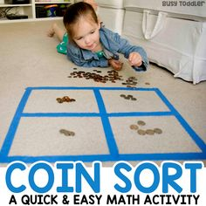
Ask a grown up to check their wallet or purse. Can you sort out the coins and recognise which ones they are?
Parents: If your child finds this tricky just stick to 1p, 2p and 5p.
Please do not try and work out totals yet!

Knowledge and understanding of the world/ Creative learning

Watch this episode of ‘Minibeast Adventures with Jess’.
https://www.youtube.com/watch?v=JuHg5oWF_mo

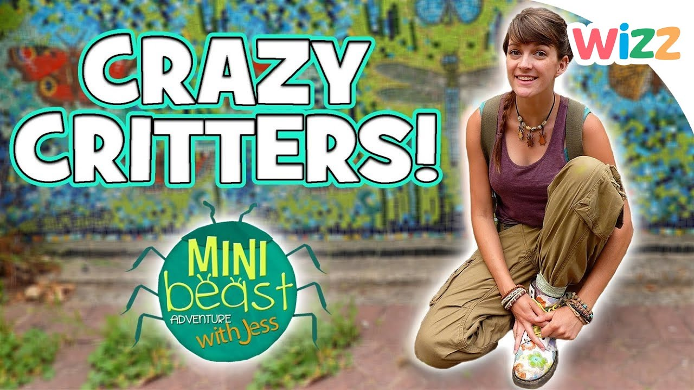

Use your purplemash log in.

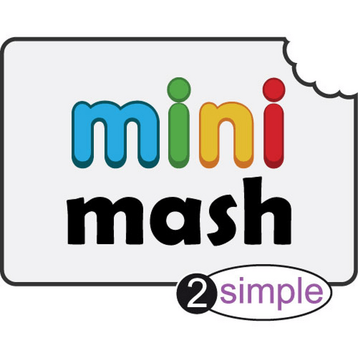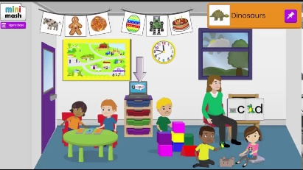
Go ‘outside’ by clicking on the door and then choose the picture of the minibeast to paint.

If you can’t access purple mash go outside in your garden or on a walk with your family. Look out for minibeasts, can you see any ants, flies, bees or even a butterfly?

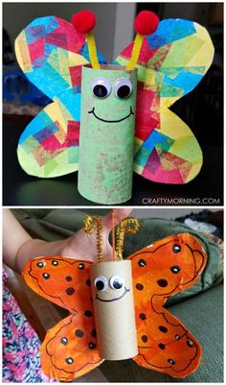
Use a toilet roll middle to make your own butterfly, draw or colour or stick on eyes. Use whatever you have at home and recycle some old paper for the wings.

Mrs Nunn and I would love to see some of your creations. Please email us some photos!
We miss you all so much.
x

