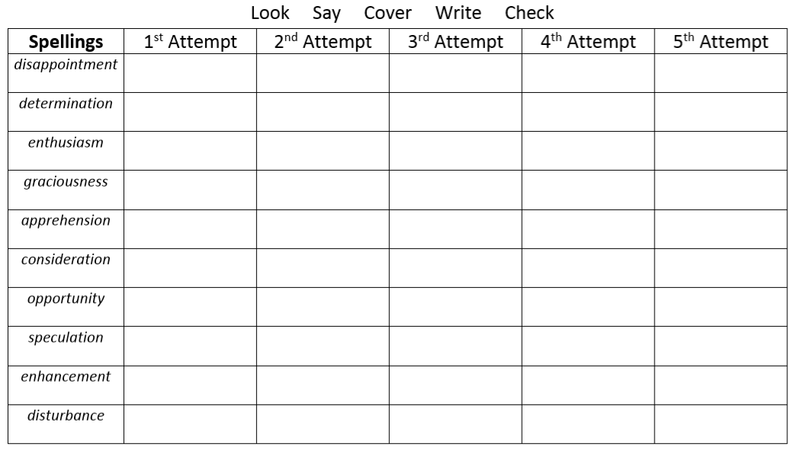
Challenge
- Appreciate 2) attached 3) available 4) average 5) awkward

