Squirrels Class – Art 22.04.20
Tin can windsock
SUPPLIES NEEDED:
- Clean Recycled Can/toilet roll tube/pringles tube (any size will work!)
- Acrylic Paint & Paintbrushes
- Glue
- Assorted Ribbons (you could also use Yarn, Colored Paper, etc.)
- Optional embellishments like Glitter, Stickers, Gemstones, Sequins, etc. as desired
- Masking Tape or any other tape
Tip: line the inside rim of the cans with a layer or two of thick masking or duct tape to avoid sharp edges!
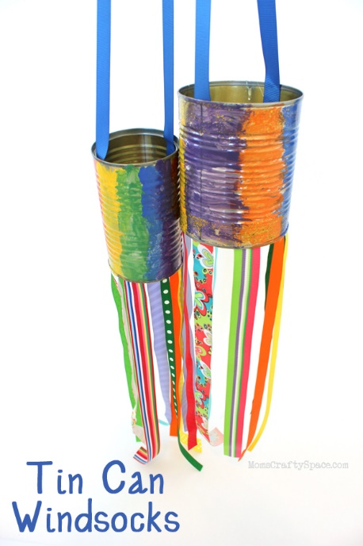
Start by painting the can in colors of your choice.
After the paint is dry, use glue to attach colorful ribbons to the bottom rim of the can. We also added a ribbon to the top of the can for hanging.

