Squirrels Class – Art 29.04.20
Button Art Tree
SUPPLIES NEEDED:
- White card/paper
- Brown paint/brown coloured felt tip pen
- Colourful buttons/cut out small circles with coloured paper
- Pva glue/glue stick (if using coloured paper circles/or different shapes)
Start by painting/drawing the tree on card/paper.
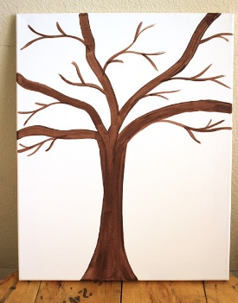

Use a small amount of PVA Glue to attach the buttons to the canvas. If you are using coloured paper shapes, a glue stick would be just fine. Allow glue to dry.
