Topic: Once upon a time

In term 4, we learnt about fables. This term, we are learning about Fairy-tales.

Below are two settings. One from Cinderella and one from the ‘Three Little pigs.’

[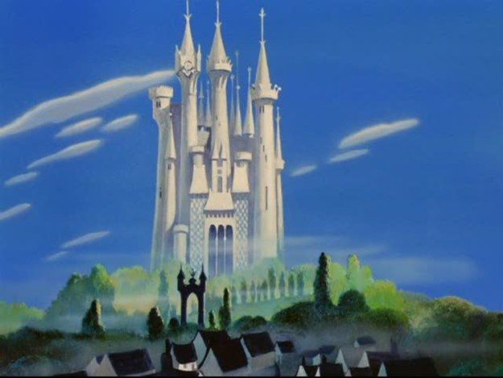](https://www.google.co.uk/url?sa=i&url=https%3A%2F%2Fwww.pinterest.com%2Fpin%2F372039619198813886%2F&psig=AOvVaw0E55oZh7mlhGWEtOrT64R5&ust=1587397557087000&source=images&cd=vfe&ved=0CAIQjRxqFwoTCJDUpvHq9OgCFQAAAAAdAAAAABAJ)Cinderella’s Castle:

What would be the best place for a Castle? (E.g. Hill, Woods, Near water?)

Do they need to have lots of food?

Why?

[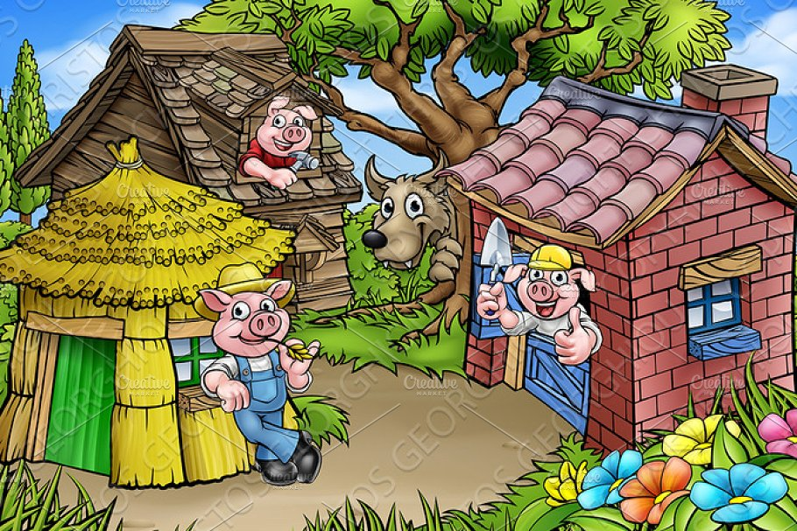](https://www.google.co.uk/url?sa=i&url=https%3A%2F%2Fcreativemarket.com%2FGeoImages%2F1915221-Fairytale-The-Three-Little-Pigs-Cartoon-Scene&psig=AOvVaw3qgiaGtOEvxU1bcaItInnD&ust=1587397680678000&source=images&cd=vfe&ved=0CAIQjRxqFwoTCPiMs63r9OgCFQAAAAAdAAAAABAD)The Three Little Pigs:

Where in Great Britain would all these materials be found?

Why?

What materials do the three pigs need?

Find the Great Britain on this map:

<https://mapchart.net/europe.html>

Look at the two settings above:

What do you think the best location would be for each picture?

* Use the questions next to the pictures to help you.
* Do some research on Great Britain and find out where these settings would be best placed?

Layout:

The best location for Cinderella’s castle would be_________________.

This is because, ______________________________________________________________________________________________________________________________________________________________________________________.

The best location for ‘The three little pigs’ homes would be ___________________.

This is because, ______________________________________________________________________________________________________________________________________________________________________________.