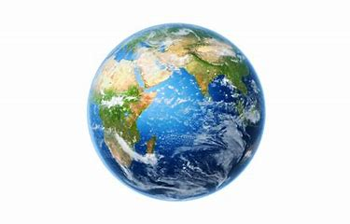
Topic- Geography
In Geography we have been comparing non-European countries to the UK.
Last week you picked a non-European country to research and hopefully learnt a little about its physical features, these are natural (hills, rivers, beaches, rainforests, weather) and human features which are man-made (towns, villages, roads, shops, factories).
This week you can create either a poster, piece of writing, labelled picture, Word document, Powerpoint or video about what you have found out.
I can’t wait to see your work and I expect I may even learn some super facts!

