Topic 20/04/30

Constellations

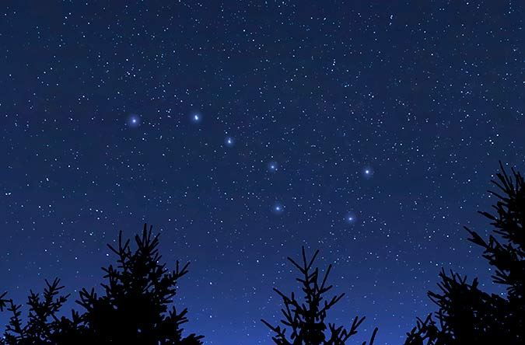

A constellation is a group of stars that forms a pattern that is usually an animal, a mythical creature / person or an object.

This is URSA MAJOR; it’s one of the easiest constellations to spot in the sky.

What does Ursa Major mean?
How would you find it in the night sly, what strategy would you use?
See if you can find it.

This is only part of the constellation. Draw a completed Ursa Major.

Extension: Ursa Major rotates around a particular star, what is it? Draw and label the journey.

