World in a Box
You will need:
- An empty box – any size. Could be a shoe box, an empty cereal box, or a tiny matchbox – use whatever you can find.
- Plain white card/paper
- Coloured card/paper
- Paper for collage (e.g. old magazines, old books, postcards, leaflets etc)
- Selection of fabric, wool, string etc
- Selection of small found objects (e.g. matchsticks, cocktail sticks, beads etc)
- Glue
- Scissors
- Pens and pencils
- Printer (optional only if you can print from home)
What to Do:
1. You need to feel as if they own your world in a box – its will be yours and it can contain anything you like.
2. You might choose to create a world which:
- Depicts your bedroom (real or fantasy)
- Shares a hobby or pastime, or something you really like (pets, objects, places)
- Depicts a dream world you would love to inhabit
- Shares a happy memory (a holiday, a person, a visit…)
- Depicts friends or family
3. Don’t worry about designing your box on paper. Instead, start making straight away, using the materials you have available. To help this process, make sure you have collected together a wide variety of materials for them to use to collage and create. The greater the variety of materials the more you can make thoughtful decisions about which materials you use and how you use them.
4. Start with either the box cover, or the interior – it doesn’t matter
5. Have creative fun!

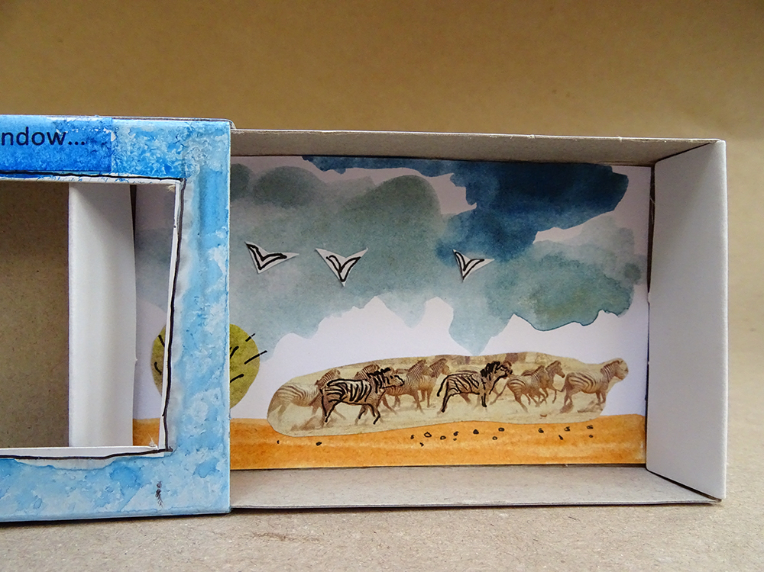

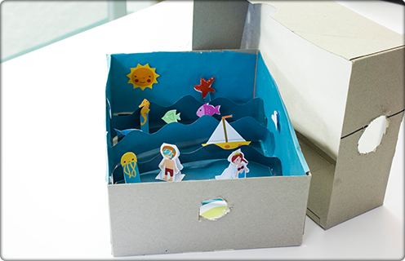

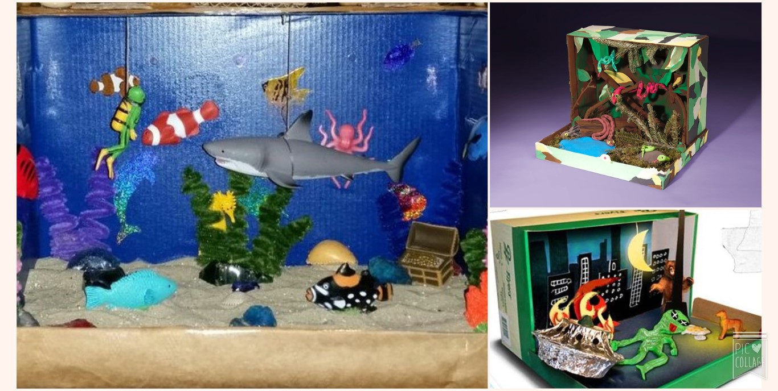
REMEMBER this is optional and can be done at any time!

