29th April
Go to the following web page:
https://whiterosemaths.com/homelearning/year-6/
Watch the tutorial on lesson 2 and 3 called Angles in regular polygons and problem solving. Complete as many of the questions as you can. Don’t worry if you can’t do them all.
Only look at the answers once you have had a really good try at the questions.

If you find these difficult have a go at the following:
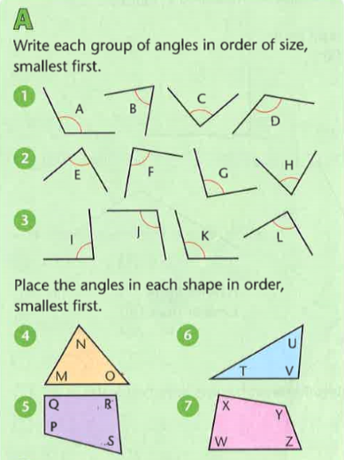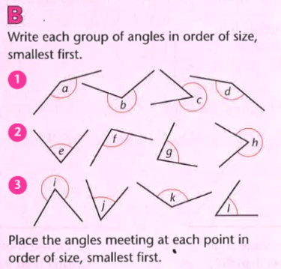

Find the answers on the next page.

Answers
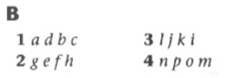

Extension
