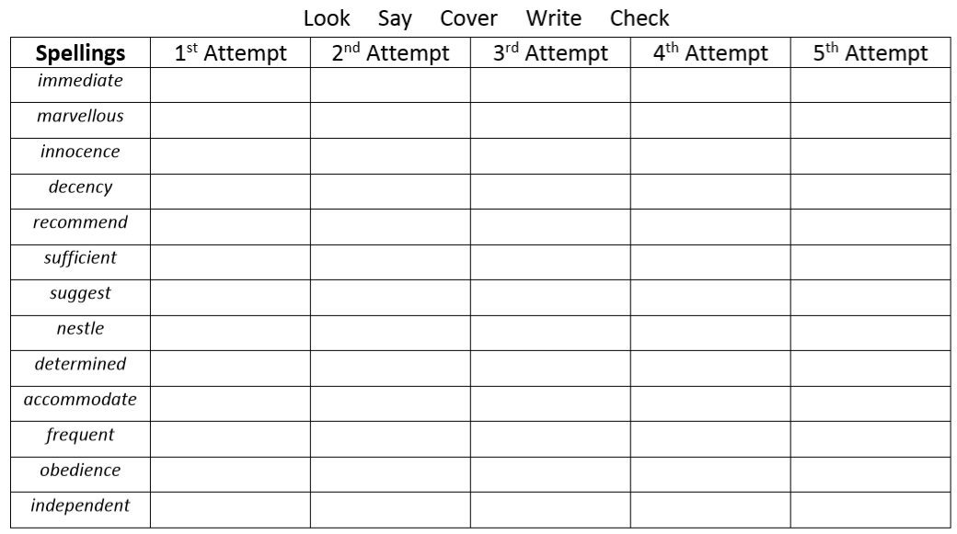
Challenge words
accompany
according
achieve
aggressive
amateur

