Art
In Art today, I am going to introduce you to a new artist. His name is Andy Warhol. He is famous for ‘Pop Art.’ Pop Art is based on Modern Culture. It uses bright colours and focuses on the main news at the time.
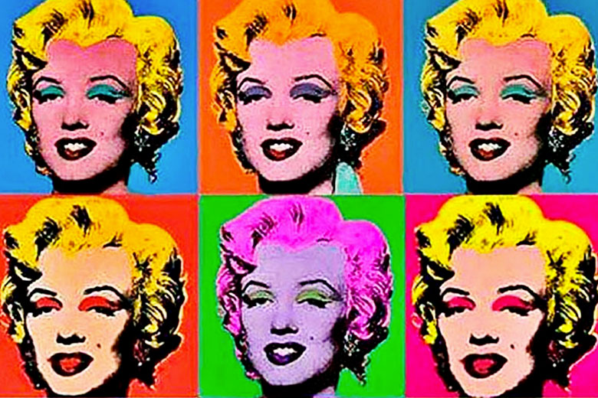
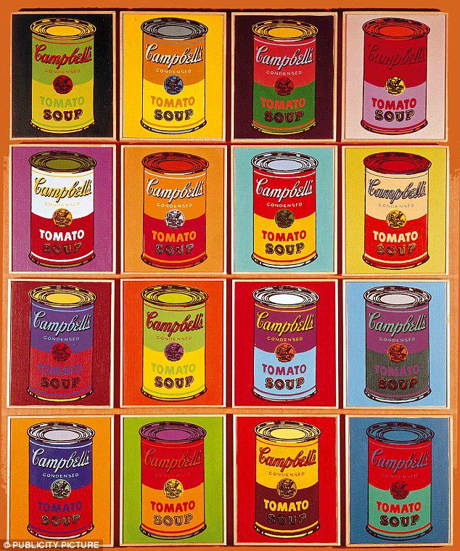
Here is some of his artwork:

Activity – We are going to focus on the picture on the left… Campbells Soup Tins.
- First, find 4 pieces of paper.
- Then, Find a fun food tin in your house.
- Next, draw the tin on each piece of paper.
- Finally, using paint, colouring pencils or collage, colour in your drawings.

Get creative and see if you can make amazing Pop Art!

