Art:
Activity 1:
This is just a little activity for the children to have a go at drawing a face. Follow the link and this gives you a step by step way of drawing a face.
- Add colour to the picture to make it more detailed.
https://content.twinkl.co.uk/resource/54/64/t2-a-004-how-to-draw-a-face-instructions-_ver_2.pdf?__token__=exp=1589301378~acl=%2Fresource%2F54%2F64%2Ft2-a-004-how-to-draw-a-face-instructions-_ver_2.pdf%2A~hmac=1aff9a3126b172c1cbae819a25dad1c5d20139f1ac2c0259bf2d006a851a8ee4

Activity 2: Printing using Tin Foil
- Find some tin foil in the house.
- Find some cardboard.
- Wrap a sheet of tin foil around the cardboard.
- Using a pencil, begin printing your design onto the tin foil.
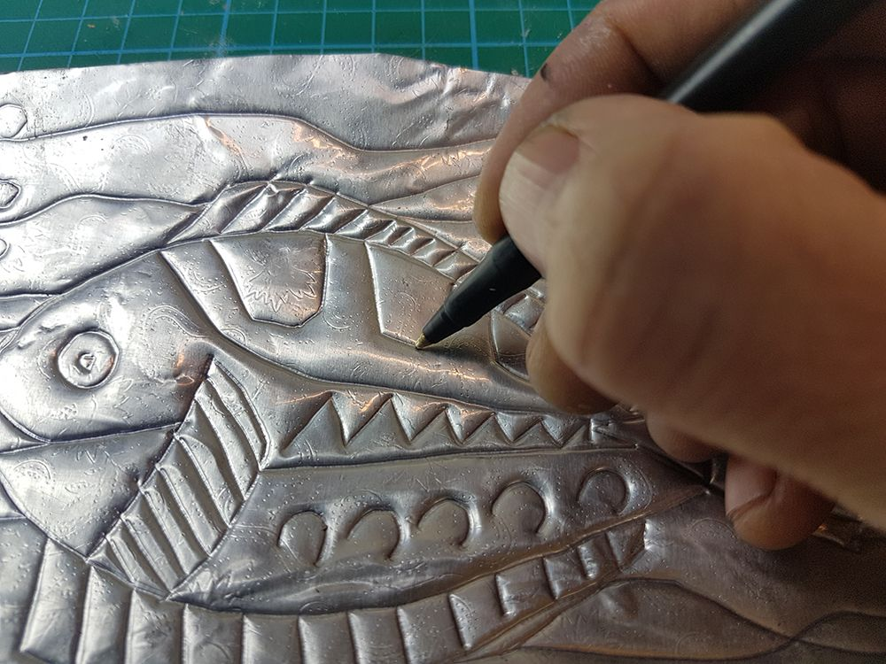
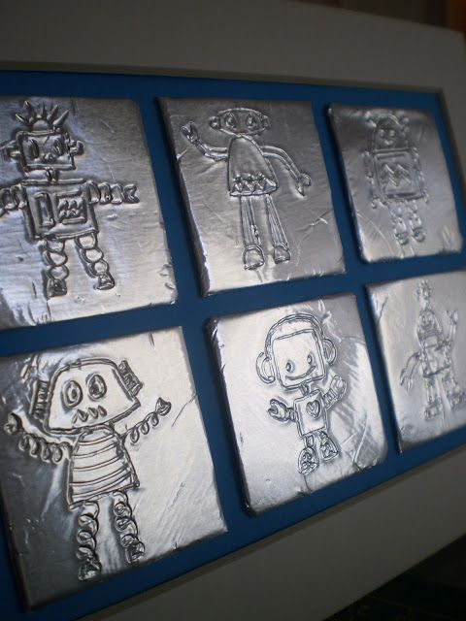
- There are some examples below.
