English –
Today, I would like you to write a diary entry. Below is the link to a video retelling a version of Cinderella.
https://www.youtube.com/watch?v=0Z6ha1UWt3w
- Pause the video on each page and read it to your adult.
You can choose from whose perspective you wish to write the entry:
- Cinderella
- The Prince
- The Stepmother
- A Stepsister

Remember: You are now that person, so you need to use pronouns such as ‘I, me, my and we.’

Look below at the features of a diary entry and use the questions to help you with the paragraphs of your diary.

Check that you have used all of the features in your Diary Entry
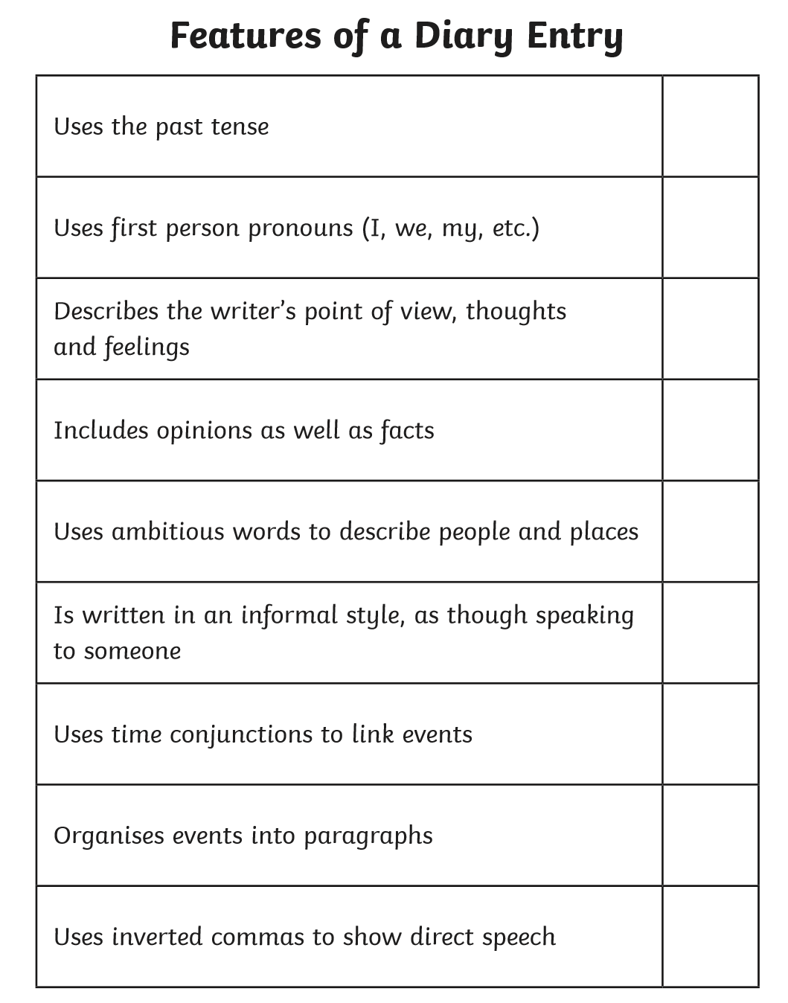

Plan: Answer the questions on scrap paper and work through your Diary Entry from there.
Paragraph 1:
Introduce the setting
- Where are you?
- What part of the story are you focusing on?
- What happens at the beginning of that part of the story?

Paragraph 2:
Feelings
- How are you feeling at this point?
- What do you think of the other people in the situation?

Paragraph 3:
Ending
- What was the ending to the situation that has just occurred?
- What do think about the situation?

Challenge: Write a diary entry using another character from Cinderella who would have a very different view of the same situation.

