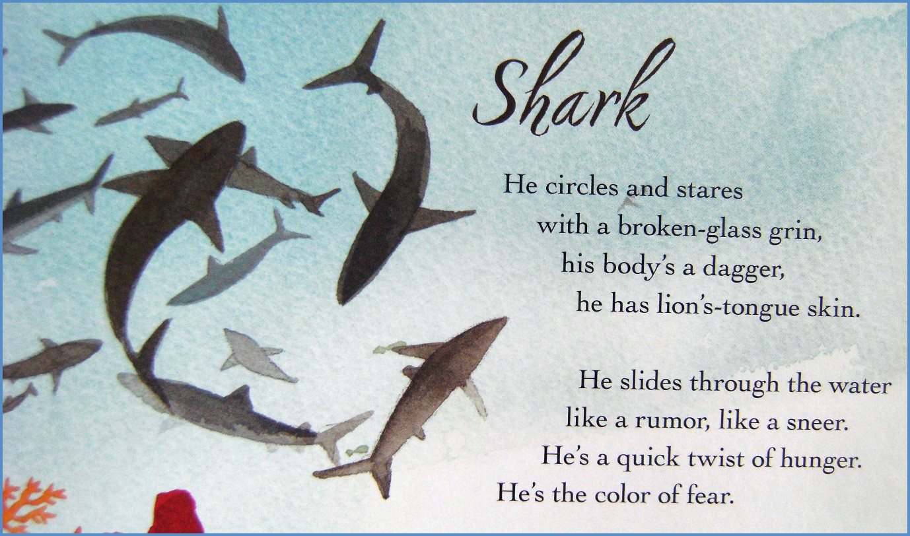
English – Reading Comprehension
colour

by Kate Coombs

Green/Red – Read through the poem ‘Sharks’ all the way through.

- Who wrote the poem?
- Write down 4 rhyming words in the poem.
- Write down 3 verbs (describing words) in the poem.
- Can you find the simile in the poem?
- Can you name 2 objects that are sharp in this poem?

Blue – Read through the poem ‘Sharks’ all the way through.

- Write down 4 rhyming words in the poem.
- Write down 3 verbs (describing words) in the poem.
- Can you write down 5 similes and metaphors within the poem?
- Can you write down 2 objects that are sharp in this poem?
- What word means ‘nasty smile?’

