Monday 4th May – Reading Comprehension
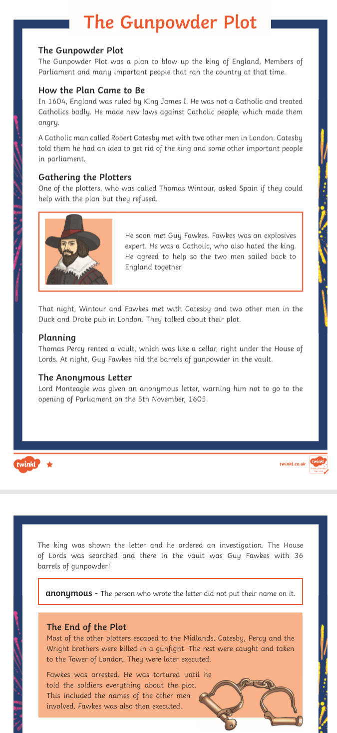
Green / Red
Questions:
- What year was the Gunpowder Plot bombing supposed to take place?
- Why did Catholics not like King James I (1st) of England?
- Who had the idea of the Gunpowder Plot?
- Where did Thomas Wintour go to ask for help?
- Name the one thing that made Fawkes a good choice for helping the plotters.
- Where did the plotters meet to discuss the plan?
- What did Thomas Percy rent the vault for?
- What word means that Lord Monteagle did not know who sent him the warning letter?
- What was Guy Fawkes found with when he was arrested?
- What information did the soldiers want from Guy Fawkes when they questioned him?
Blue

Questions
- In your own words, explain what the Gunpowder Plot was aiming to achieve?
- Why did Catholics not like King James I (1st) of England? Explain your answer.
- When did Robert Catesby first tell others about his idea?
- What does ‘replant the Catholic faith’ mean?
- Why did the Spanish not agree to help with the plot?
- Why do you think Catesby’s men ‘swore and oath to secrecy’?
- How did the practical arrangements of the plan change?
- Why do you think the barrels of gunpowder were hidden ‘under the cover of darkness’?
- Why do you think the letter to Lord Monteagle was sent anonymously?
- Explain in your own words, why you think Catesby would not be persuaded to give up on his plan?
- What made Guy Fawkes look guilty when he was found in the vault.
- Why do you think that Fawkes did not confess straight away?

